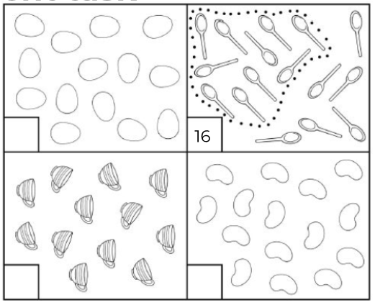
Count the objects and write the number in the box.

