Anansi
E2
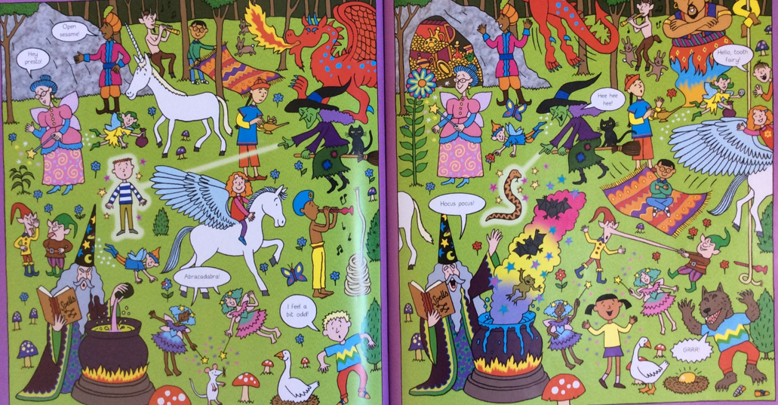
Anansi found a moss covered rock that had the power to make you fall asleep. If you fall asleep, what would you dream about becoming?
E.g., I will be a red dragon.
___________________________________________________________________________________________________________________________________________________________________________________________________

