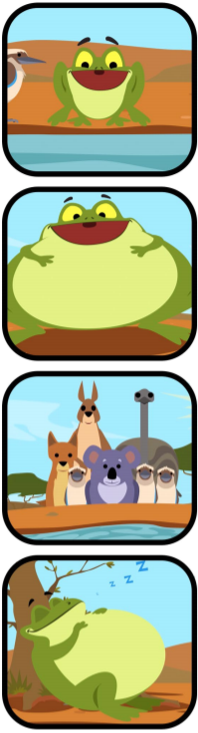
Tiddalik
E10
Write a caption to explain what is going on in each picture.
_
_____________________________________________________________________________________________________________________

_
_____________________________________________________________________________________________________________________

_
_____________________________________________________________________________________________________________________

_
_____________________________________________________________________________________________________________________

