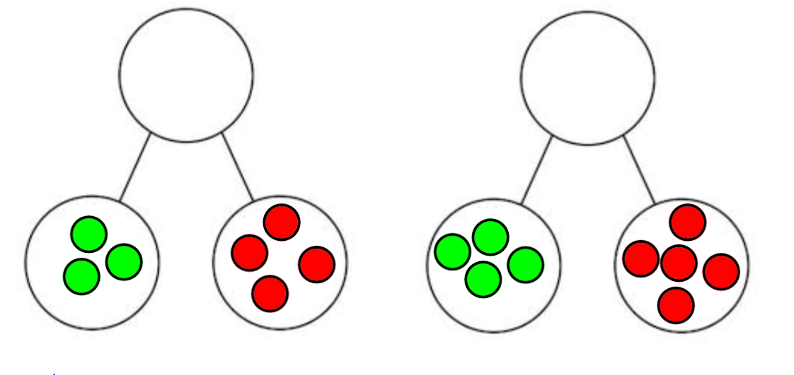
Can you count the dots in each part to find the whole number?
M1
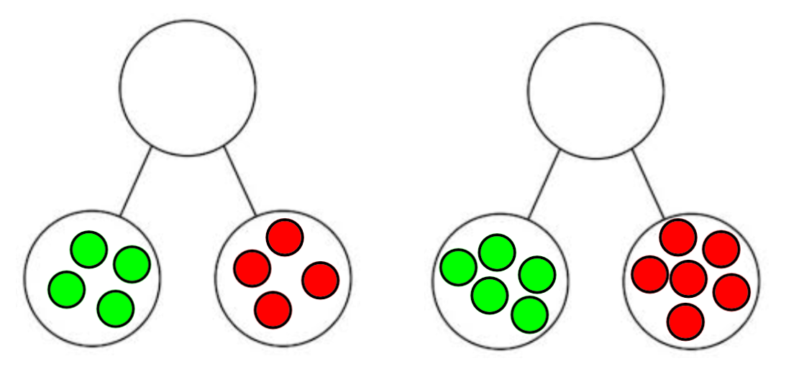
What number sentences do these part whole diagrams show?

