M4
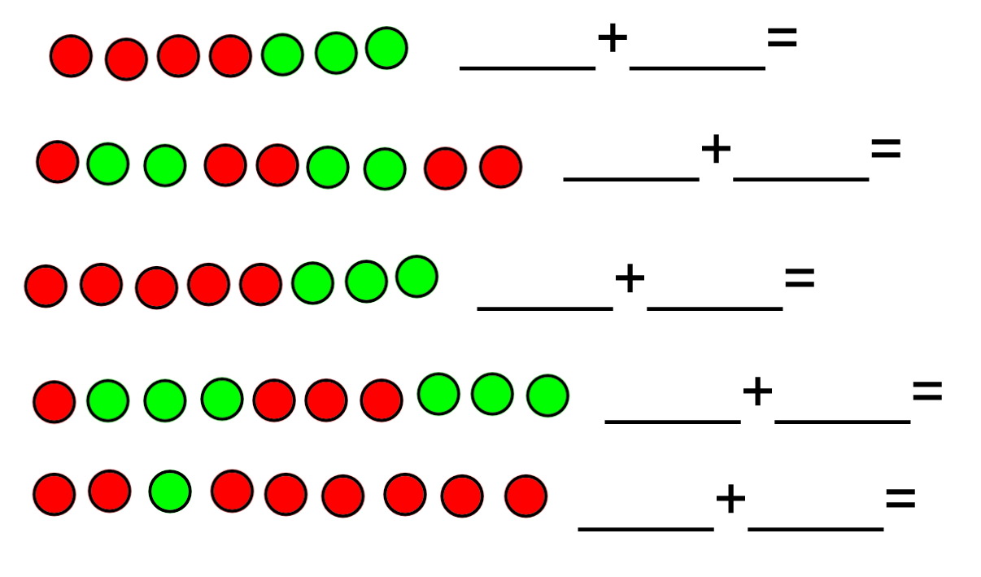
Today you are going to build a number sentence and solve it. Count the red and green counters, write down the number sentence it shows and then count them altogether to find the total. Remember it addition is commutative and it does not matter what number you start with you will still get the same answer!
Can you create your own addition number sentences using your jottings?

