Addition
M9
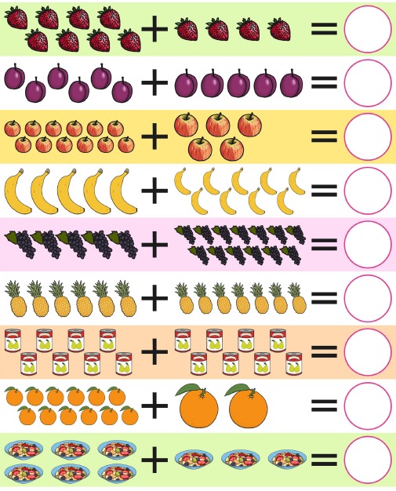
Can you count the pictures to find the total? Can you show what number sentence it represents?

