Whitefield Infant School


Year 1
Weeks 5-6
Remote Learning Pack

Year 1 Remote Learning Timetable – Spring Pack – Week 5
 | Phonics | English |  | Maths |  | Reading | Topic | Story time
Day 1 | Phase 5 ‘ai’ sound family | Character description | Break | Adding by counting on using a number line | Lunch-time | Cinderella story review | Music | You could:  Read your home reading book to an adult or sibling.  Ask an adult or older sibling to read you a story.  Read or listen to a story on Oxford Reading Owl.  Listen to a story https://www.bbc.co.uk/cbeebies/stories
Day 2 | Phase 5 ‘ee’ sound family | Sentence work | Break | Subtracting by counting back using a number line | Lunch-time | Fiction text – reading practise | Geography – Landmark comparison
Day 3 | Phase 5 ‘igh’ sound family | Fact file | Break | Adding using known number facts | Lunch-time | Understanding the text – matching activity | P.E
Day 4 | Phase 5 ‘oa’ sound family | Sentence work – extending sentences with ‘and’ | Break | Subtracting using known number facts | Lunch-time | Non- Fiction text – reading practise | Science – Materials – floating and sinking
Day 5 | Phase 5 ‘ue’ sound family | Story sequencing | Break | Adding using the ‘make 10’ strategy | Lunch-time | My favourite part | Art – Klimt

Year 1 Week 1
Day 1
Phonics
Today you are going to take part in a phonics lesson all about the ‘ai’ sound family. Follow the link to Mr Thorne does phonics’ youtube channel to watch today’s phonics lesson.
https://www.youtube.com/watch?v=UCE3ZO0Rc0E
Once you have watched the video, find worksheet P1 in your learning pack and complete the activities.
English
This week our learning in English will be linked to the traditional tale ‘Anansi’
Follow the link to watch part 1 of the story online.
https://www.bbc.co.uk/teach/school-radio/english-ks1-anansi-and-the-moss-covered-rock-part-1/zhj4382
Look at the picture of Anansi, use the word bank and choose the words that describe him. Can you put these words into sentences to write a mini description?
Find worksheet E1 in your learning pack and complete the activity.
Maths
This week in Maths, we will be exploring addition and subtraction.
Today in maths, you are going to be exploring how to add by counting on using a number line.
Click on the link to watch today’s maths lesson.
https://classroom.thenational.academy/lessons/to-add-by-counting-on-using-a-number-line-ccukct?activity=video&step=1
When you have watched the lesson find worksheet M1 in your learning pack. Can you solve the addition number sentences using the number line to help you?

Reading
Click the link to watch the story of Cinderella on Espresso
https://central.espresso.co.uk/espresso/primary_uk/subject/module/video/item688943/grade1/module688839/index.html
You might need to log in to Espresso using the log in below:
Username: student18029
Password: nwi123
Once you have watched the story video find the worksheet R1 in your learning pack. You can draw pictures or write sentences to complete your story review.
Topic- Music
This afternoon we are going to learn a song linked to one of our traditional tales books Jack and the Beanstalk. During the lesson you will learn about long and short notes and repeated verses. Click on the link for the tutorial
https://www.bbc.co.uk/teach/school-radio/music-jack-and-the-beanstalk-song1/z7m67nb


P1 Tick the words if you can read them.
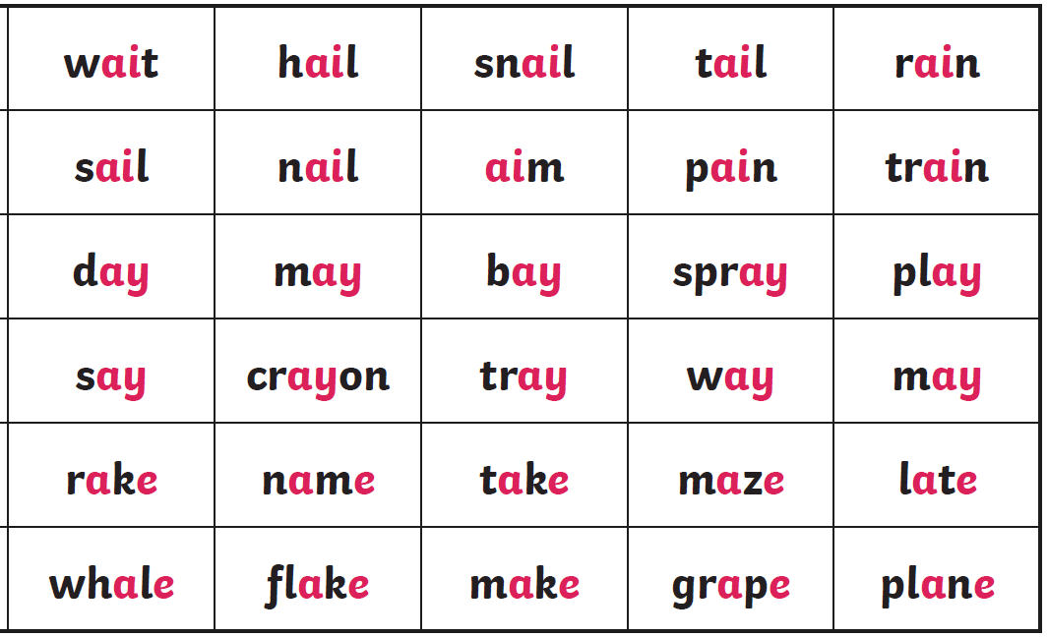
Can you sort the words into the right spelling group?
ai | ay | a_e
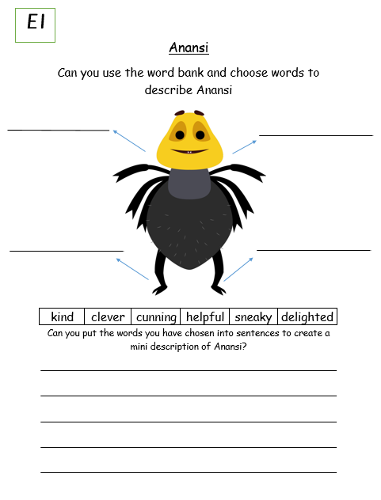
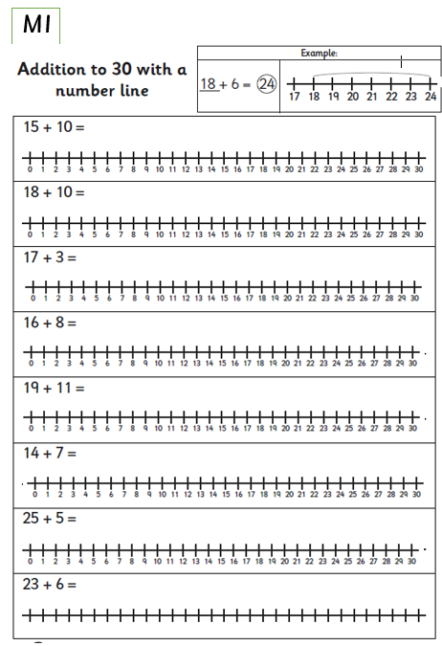
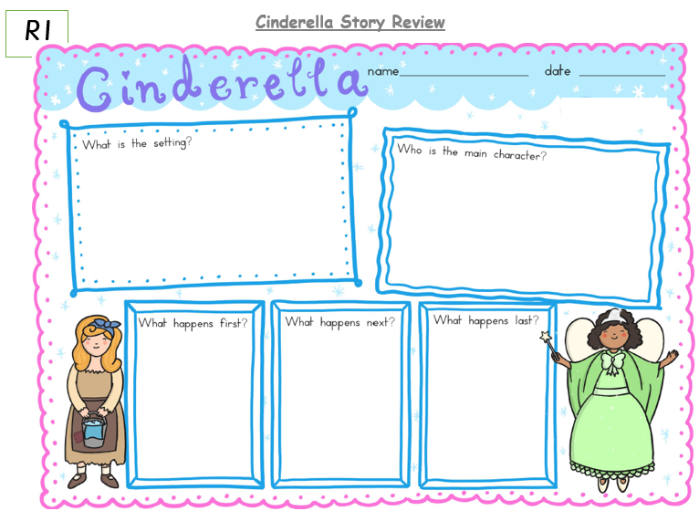
Day 2
Phonics

Today you are going to take part in a phonics lesson all about the ‘ee’ sound family. Follow the link to Mr Thorne does phonics’ youtube channel to watch today’s phonics lesson.
https://www.youtube.com/watch?v=WO1ylMaWf0w

Once you have watched the video, find worksheet P2 in your learning pack and complete the activities.

English
Yesterday you watched the traditional tale video of Anansi. In the story, Anansi found a moss covered rock that had the power to send people to sleep. Have a think, when you go to sleep what do you dream about? Use the picture to help you with your ideas (the wilder the better!) and write sentences about your dreams.

Find worksheet E2 in your learning pack and complete the activity.
Maths
Today in maths, you are going to be exploring how to subtract by counting backwards on a number line.
Click on the link to watch today’s maths lesson.
https://classroom.thenational.academy/lessons/to-subtract-by-counting-back-using-a-number-line-cgr36d

When you have watched the lesson find worksheet M2 in your learning pack. First you need to look at the pictures carefully and talk about the number story. How many are there at the beginning? How many are taken away? How many are left? Use the number line to help you solve the problem and then write the number sentence.

Reading
Follow the link to the Oxford Owl reading site. https://www.oxfordowl.co.uk/
You will find the class login for Oxford Owl in your online login books.
Choose a fiction book that matches the coloured book band you are on. Once you have read the book see if you can answer these key questions.
- Who is the main character in your book?
- Where is the story set?
- What is the main event in the story?
- What was your favourite part and why?
Topic - Geography
So far you have done lots of learning all about London. Today I want you to watch https://www.youtube.com/watch?v=MHxSq4c_E6g And recap all the main London landmarks. Could you remember any? Now I want you to have a think and compare these to landmarks in your own hometown. How are they similar or different?

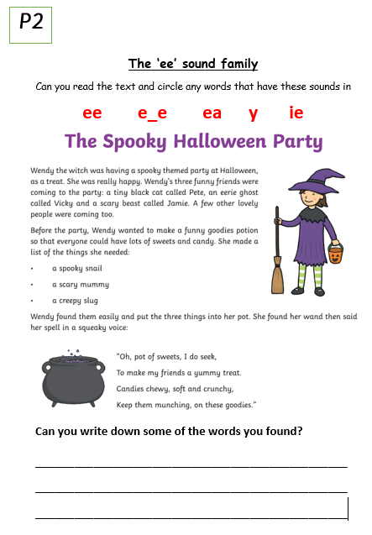
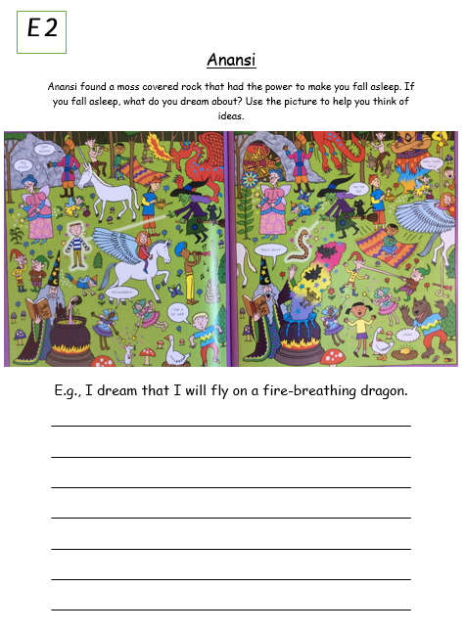
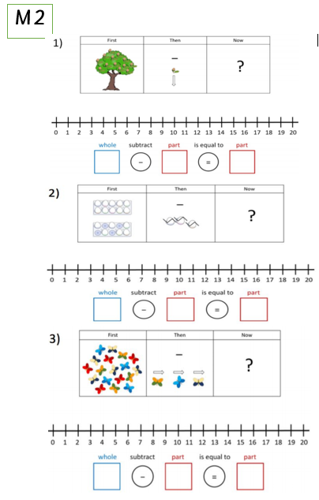
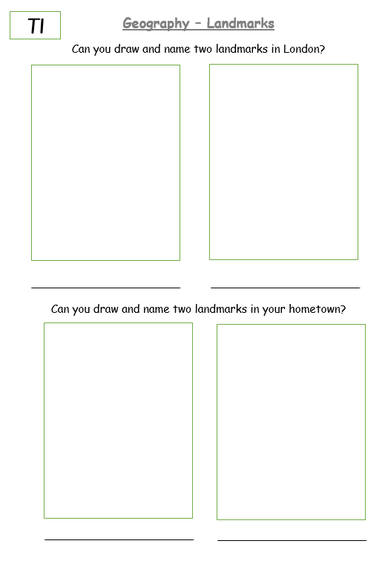
Day 3
Phonics
Today you are going to take part in a phonics lesson all about the ‘igh’ sound family. Follow the link to the youtube channel to watch today’s phonics lesson.
https://www.youtube.com/watch?v=Eq03JYcHGZU

Once you have watched the video, find worksheet P3 in your learning pack and complete the activities.
English
Anansi is a spider. Watch the Espresso video on spiders by following the link https://central.espresso.co.uk/espresso/primary_uk/subject/module/video/item1158221/grade1/module1149557/index.html
You might need to log in to Espresso using the log in below:

Username: student18029
Password: nwi123
What have you learnt about spiders? Can you remember some simple facts and create your own fact file? For example what do spiders look like? Where might you find a spider? What do they eat? Find and complete the worksheet E3 in your learning pack.

Maths
Today in maths, you are going to be exploring what happens to numbers when you add 10. You are going to be looking for patterns in numbers and using the number facts you already know to help you.
Click on the link to watch today’s maths lesson.
https://classroom.thenational.academy/lessons/to-add-a-1-digit-number-to-a-teens-number-using-a-known-fact-69gkat

When you have watched the lesson find worksheet M3 in your learning pack.
Reading
Click the link to watch the story of ‘Jack and the Beanstalk’ on Espresso
https://central.espresso.co.uk/espresso/primary_uk/subject/module/video/item688955/grade1/module688839/index.html
You might need to log in to Espresso using the log in below:
Username: student18029
Password: nwi123
Once you have watched the story video find the worksheet R2 in your learning pack.
Can you read the captions from the story and match them to the right picture?

Topic- P.E
I hope you’re ready for an energetic PE session with the body coach! Click on the link to get sweaty https://www.youtube.com/watch?v=hozv0a23eKk

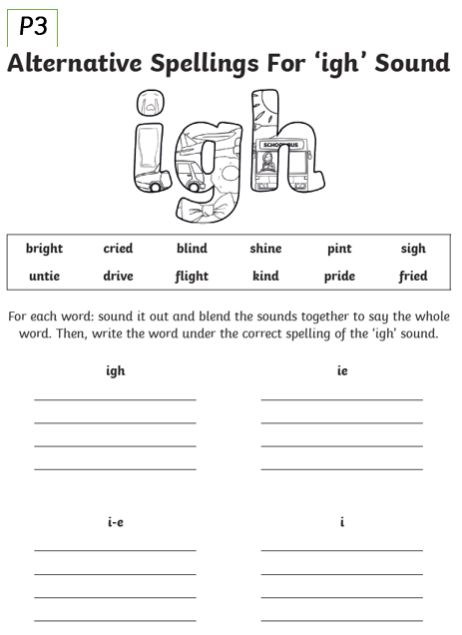
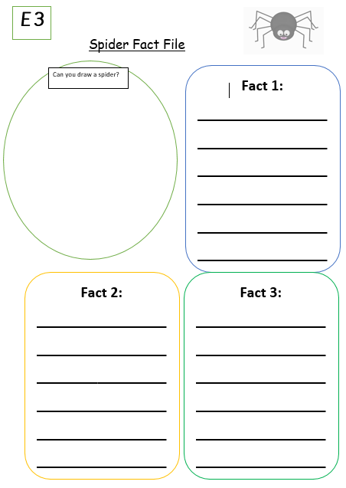
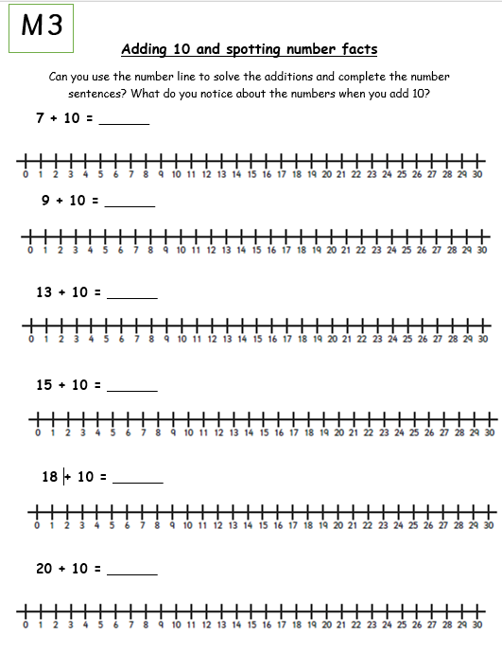
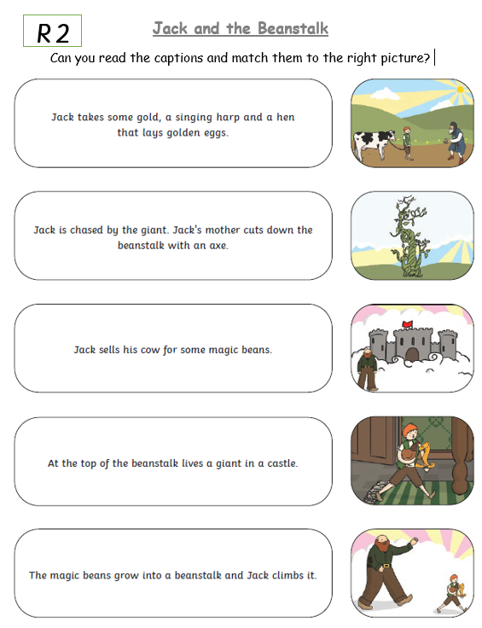
Day 4
Phonics

Today you are going to take part in a phonics lesson all about the ‘oa’ sound family. Follow the link to Mr Thorne does phonics’ youtube channel to watch today’s phonics lesson.
https://www.youtube.com/watch?v=Q-90smlX7ws
Once you have watched the video, find worksheet P4 in your learning pack and complete the activities.
English
Watch the part 2 of the Anansi story by following the video link https://www.bbc.co.uk/teach/school-radio/english-ks1-anansi-and-the-moss-covered-rock-part-2/zf78rj6

Anansi was very cunning in the story but the deer was even smarter. How did the deer manage to trick Anansi in the end? Can you explain it by writing some sentences? E,g The deer tricked Anansi by …
As a challenge try to use the joining word ‘and’ to extend your sentences.
After watching the episode, find worksheet E4 in your learning pack.
Maths
Today in maths, you are going to use the subtraction number facts you already know to help you subtract bigger value numbers. For example if you know 5-3=2 you can link this fact to 15-3=12.
Click on the link to watch today’s maths lesson.
https://classroom.thenational.academy/units/addition-and-subtraction-within-20-79fd

When you have watched the lesson find worksheet M4 in your learning pack.

Reading
Follow the link to the Oxford Owl reading site. https://www.oxfordowl.co.uk/
You will find the class login for Oxford Owl in your online login books.
Choose a Non - fiction book that matches the coloured book band you are on. Once you have read the book tell an adult three facts that you have learnt.

Topic- Science
Today we will be thinking about which materials float and sink and you are going to create a simple experiment at home. You will need a bowl of water and some objects from around your house that you don’t mind getting wet! Click on the link below to watch the video.
https://classroom.thenational.academy/lessons/which-materials-float-and-sink-cdj66c
Once you have watched the video complete your experiment exploring which items float and sink, take some pictures and send them to your teachers!
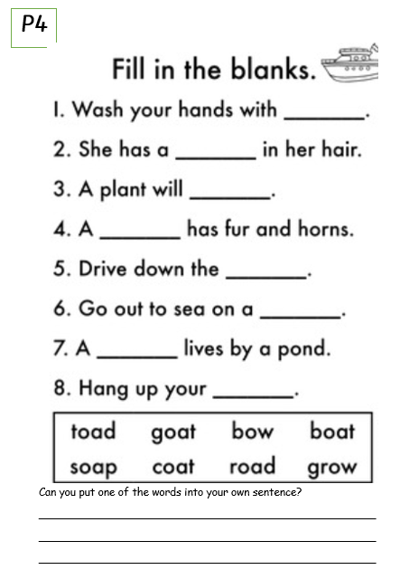
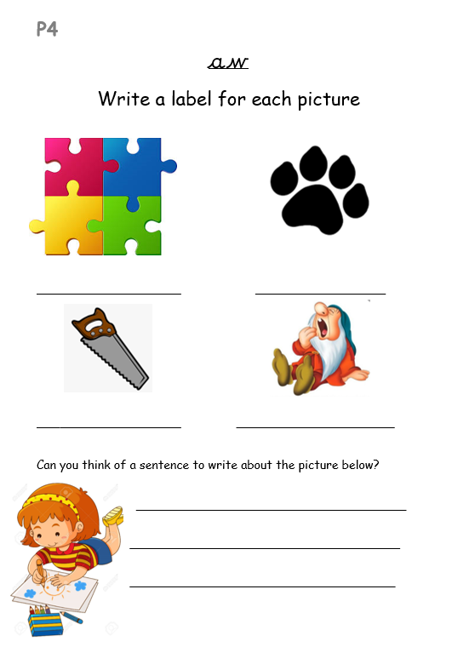
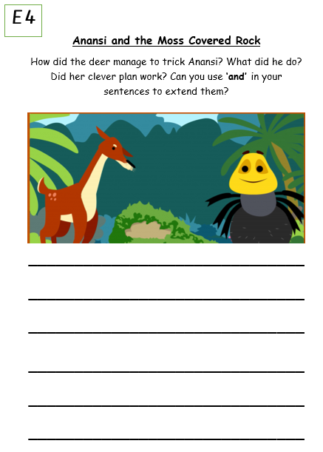
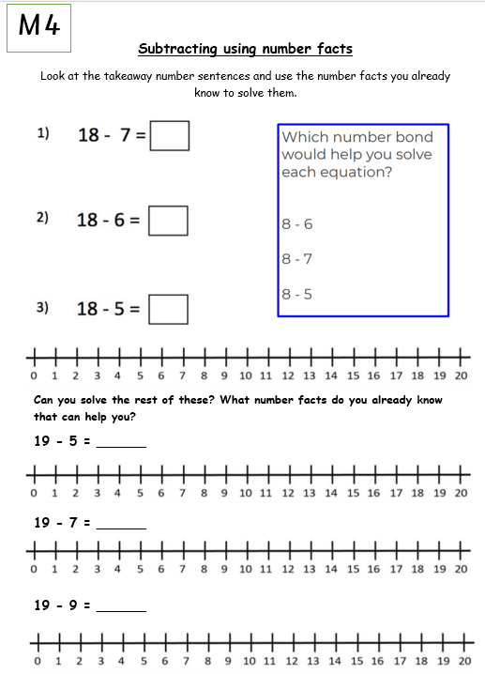
Day 5
Phonics
Today you are going to take part in a phonics lesson all about the ‘ue’ sound family. Follow the link to the Espresso page to watch today’s phonics lesson.
https://central.espresso.co.uk/espresso/primary_uk/subject/module/video/item114610/grade1/module63429/index.html
You might need to log in to Espresso using the log in below:

Username: student18029
Password: nwi123

Once you have watched the video, find worksheet P5 in your learning pack and complete the activities.
English
Today we are going to sequence the story pictures from Anansi. If you need to, watch the story video again at https://www.bbc.co.uk/teach/school-radio/english-ks1-anansi-and-the-moss-covered-rock/z4f6qp3
Talk about the story with an adult. What happened at the beginning, middle and end? Can you cut the story pictures out, put them in the correct order on the next page and retell the story?

Find worksheet E5 in your learning pack.
Maths
Today in maths, you are going to be solving addition problems using the strategy ‘make 10’. This is where you make a group of 10 and then add the remaining amount to find the total.
Click on the link to watch today’s maths lesson.

https://classroom.thenational.academy/lessons/to-use-the-make-ten-strategy-to-add-two-1-digit-numbers-part-1-70r62e?step=2&activity=video

When you have watched the lesson find worksheet M5 in your learning pack.

Reading
Click the link to watch the story of ‘The Golden Goose’ on Espresso
https://central.espresso.co.uk/espresso/primary_uk/subject/module/video/item688958/grade1/module688839/index.html
You might need to log in to Espresso using the log in below:
Username: student18029
Password: nwi123

With your adult talk about what was your favourite part of the story and why?
Find and complete the worksheet R3 in your learning pack.

Topic- Art
Here is a piece of artwork called ‘Beech Grove’ by the artist Gustav Klimt. He was famous for his paintings of trees. What do you like/ dislike about this painting? What parts of the tree can you see? Why do you think that is? How does it make you feel? Using a piece of paper, pencil and some colours can you draw your own tree scape setting? Does it look similar or different to Klimts?
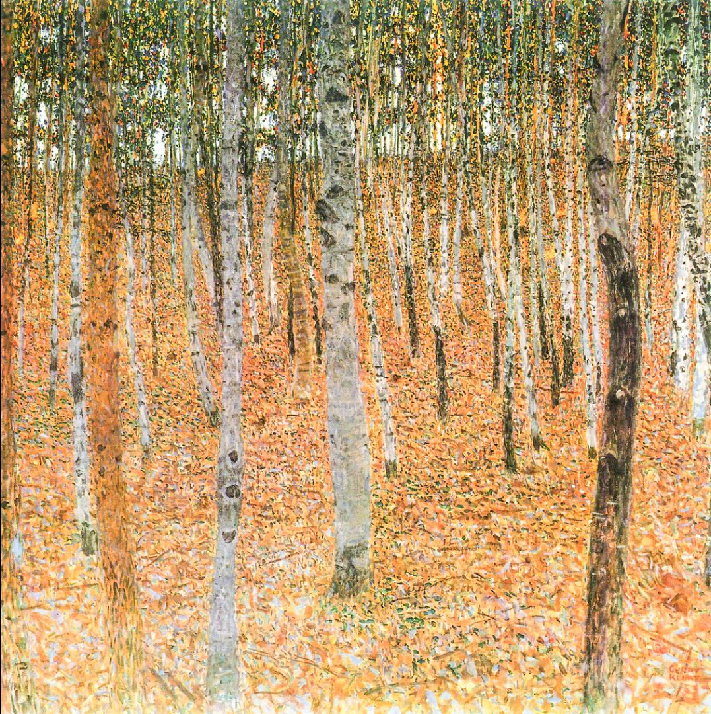
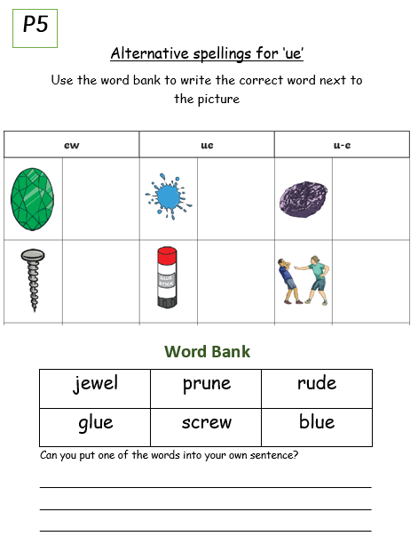

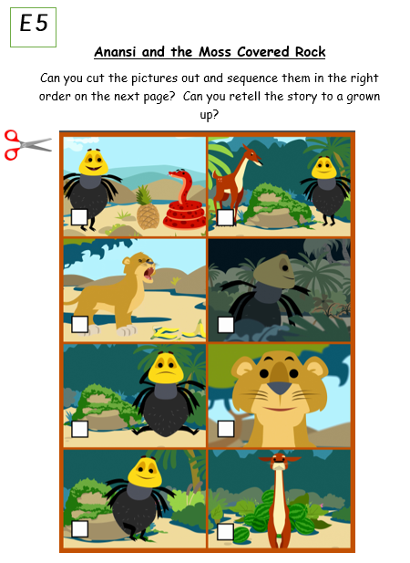
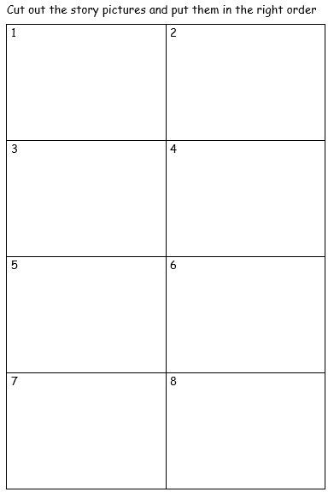
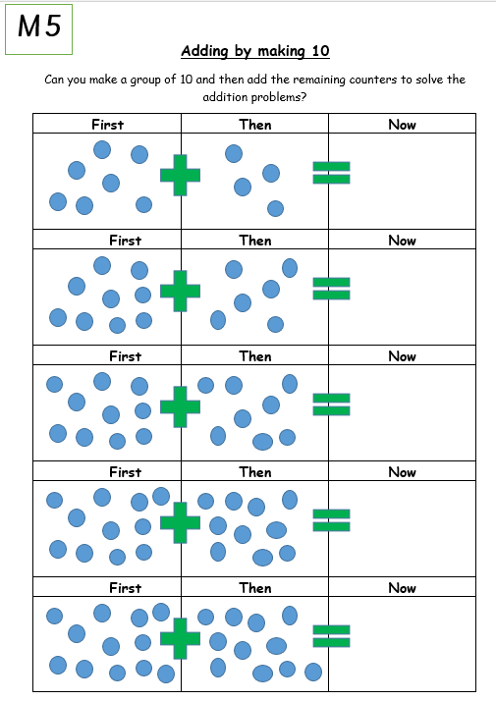
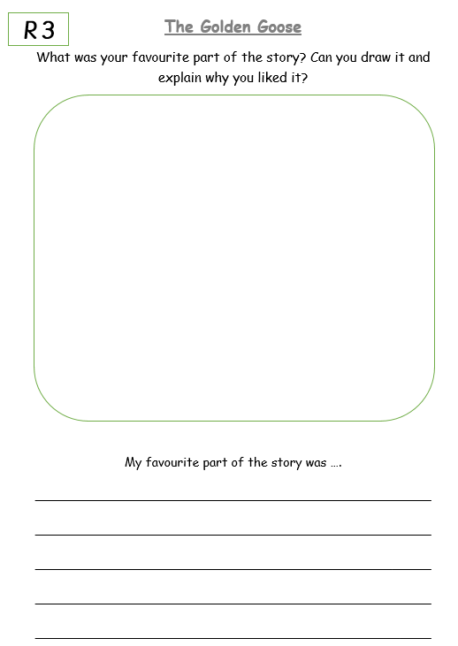

 | Phonics | English |  | Maths |  | Reading | Topic | Story time
Day 1 | Tricky Words | Character speech | Break | Addition- making 1o strategy | Lunch-time | Book summary | Music | You could:  Read your home reading book to an adult or sibling.  Ask an adult or older sibling to read you a story.  Read or listen to a story on Oxford Reading Owl.  Listen to a story https://www.bbc.co.uk/cbeebies/stories
Day 2 | Tricky Words | Non fiction – frog fact file | Break | Addition – using different strategies | Lunch-time | Character comparison | Art
Day 3 | Tricky Words | Character description | Break | Subtraction – using different strategies | Lunch-time | Sound spotting | P.E
Day 4 | Tricky Words | Invitation | Break | Addition – counting on method | Lunch-time | Oxford Owl Reading | Science – materials
Day 5 | Tricky Words | Writing captions | Break | Subtraction- counting back method | Lunch-time | Oxford Owl Reading | E-safety
Year 1 Remote Learning Timetable – Spring – Week 6
Year 1 Week 2
Day 1
Phonics
This week in phonics you are going to be looking at the tricky words across phases 2, 3, 4 and 5. These are words that cannot be read phonetically that’s why they are so tricky! They start easy but will get harder as the week goes on! Remember you need to be able to read and spell these words correctly.
Follow the link to Mr Thorne does phonics’ youtube channel to watch today’s phonics lesson. https://www.youtube.com/watch?v=uBSvtzEORlc
Once you have watched the video, find worksheet P6 in your learning pack and complete the activities.
English
In English this week we are carrying on learning about traditional tales. Click on the link below to watch part 1 of the story about a greedy frog called Tiddalik that drank all the water in the land. https://www.bbc.co.uk/teach/school-radio/english-ks1-tiddalik-the-frog/zjqkgwx
Once you have watched the video find worksheet E6 in your learning pack and complete the speech bubbles for Tiddalik and the other animals. How would the animals be feeling after Tiddalik drank all the water? What would they say to each other?
Maths
This week we are going to continue to work on addition and subtraction. Today we are carrying on with our number facts lesson last week that taught us to use our known number facts to help us solve additions and subtractions. A super set of number facts to know is our number bonds to 10. Watch the maths lesson on https://classroom.thenational.academy/lessons/to-use-the-make-ten-strategy-to-add-two-1-digit-numbers-part-2-60rk4t
And find the worksheet M6 in your learning pack. Complete the number bonds to 10 problems and use the number facts to help you complete the challenges at the bottom.
Reading
Follow the link to the Oxford Owl reading site. https://www.oxfordowl.co.uk/
You will find the class login for Oxford Owl in your online login books, which will explain how to access the texts.
Choose a text, which matches the coloured book band you are on, then find worksheet R4 in your learning pack and complete the activity. Today you are going to complete book summary of the text you have read. Can you write down the title, draw the front cover and write a few sentences to explain what happened in the story?
Topic- Music

Today we are learning about rhythm and pulse. Watch the video below to find out more and take part in the lesson.
https://classroom.thenational.academy/lessons/rhythm-and-pulse-c4tker?activity=video&step=1
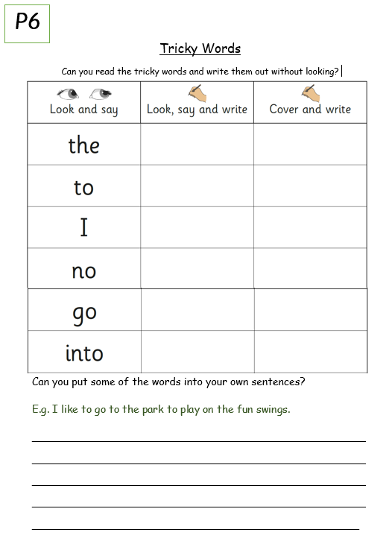
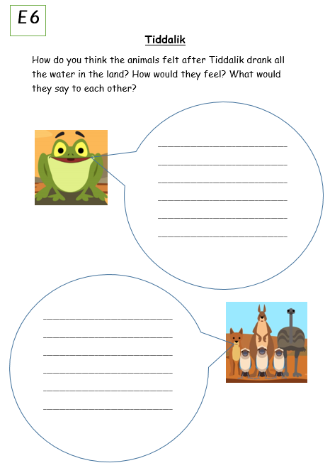
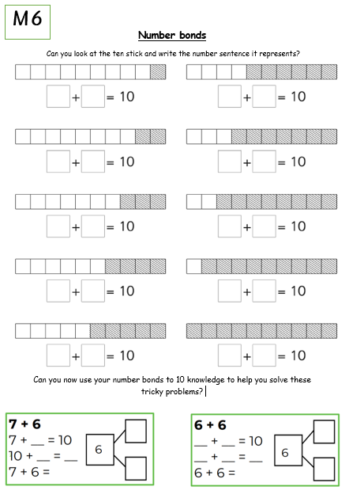
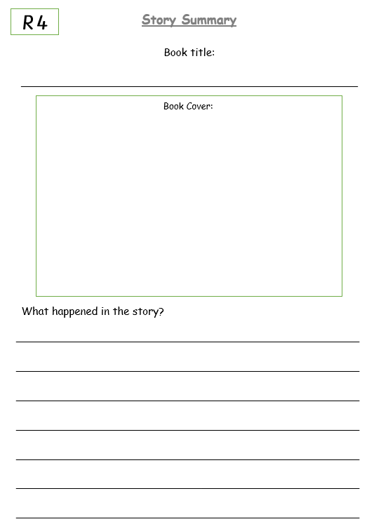
Day 2
Phonics
Today we are going to continue to look at tricky words in phase 3. Remember you have to be able to read and spell these words but be careful and don’t let them trick you!
Follow the link to Mr Thorne does phonics’ youtube channel to watch today’s phonics lesson.
https://www.youtube.com/watch?v=1sSpqLJUbiQ
Once you have watched the video, find worksheet P7 in your learning pack and complete the activities.
English
Yesterday you watched part 1 of the traditional story Tiddalik. Tiddalik is an amphibian (a frog to be precise). Today you are going to watch a video all about amphibians to learn some new facts.
https://central.espresso.co.uk/espresso/primary_uk/subject/module/video/item1155234/grade1/module1149557/index.html
You might need to log in to Espresso using the log in below:
Username: student18029
Password: nwi123

Once you have watched the video find worksheet E7 in your learning pack and create your very own frog fact file using the new information you have learnt.
Maths
Today in maths you are going to continue your learning on addition. Watch the video link to recap all the addition strategies you know.
https://classroom.thenational.academy/lessons/to-use-mathematical-models-and-strategies-for-addition-crrpcr?step=2&activity=video

Next find worksheet M7 in your learning booklet and solve the addition number problems using your preferred method.
Reading
Follow the link to the Oxford Owl reading site. https://www.oxfordowl.co.uk/
You will find the class login for Oxford Owl in your online login books, which will explain how to access the texts.
Choose a text which matches the coloured book band you are on and then find worksheet R5 in your learning pack and complete the activity. Today you are going to choose two characters from your story and compare them. What is similar about them? What is different?
Topic- Art
The weather has been crazy the past few weeks and we have had lots of snow! The trees look beautiful when they are covered in snow and today you are going to make your own. Follow the link to see how to create your very own snow tree. https://www.easypeasyandfun.com/winter-tree-finger-painting/
You will need:
- Paper or card
- Pencil or pencil crayons for the tree
- White paint (if you don’t have any of this you could always be creative by ripping up bits of white paper or tissue and sticking it on to look like snow)



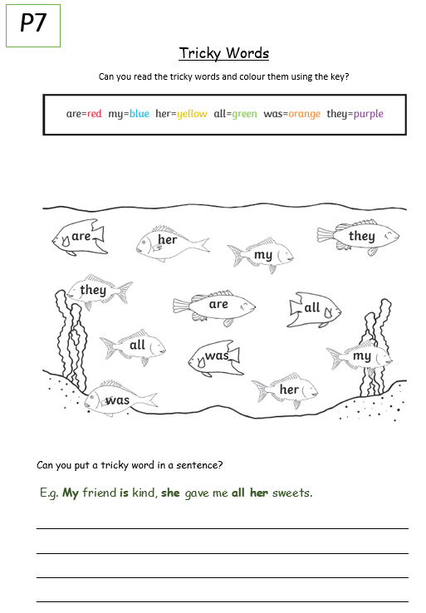
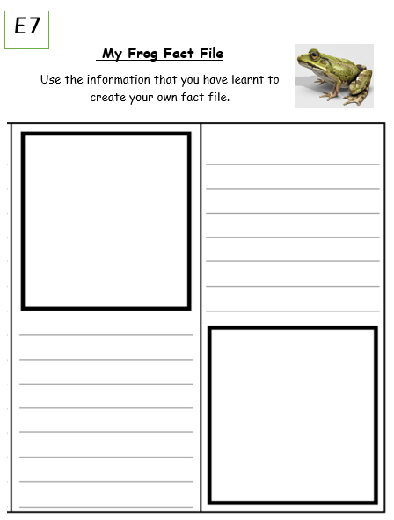
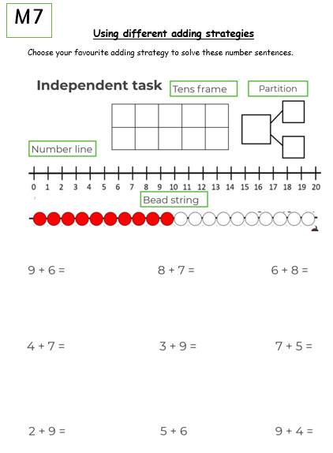
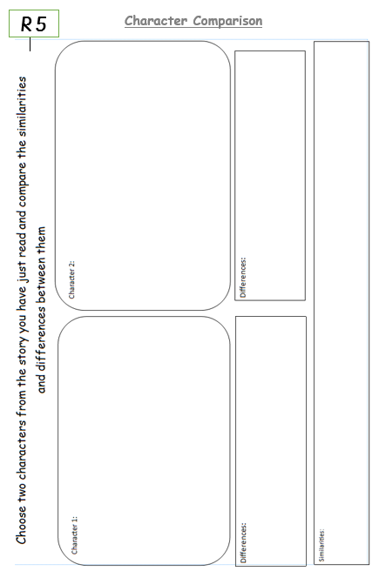
Day 3
Phonics
Today we are going to continue to look at tricky words and decodable words High frequency words in phase 4. High frequency words are the words we read most so its important to be able to read and spell them.
Follow the link to Mr Thorne does phonics’ youtube channel to watch today’s phonics lesson.
https://www.youtube.com/watch?v=ALyrYqxhwiI
Once you have watched the video, find worksheet P8 in your learning pack and complete the activities.
English
Today we are going to carry on our learning on the story of Tiddalik. If you need to refresh your memory and watch part 1 of the video again click on the link https://www.bbc.co.uk/teach/school-radio/english-ks1-tiddalik-the-frog/zjqkgwx
Tiddalik is the main character in the story. What type of character is he? Can you think of some words to describe him? Find the worksheet E8 in your learning pack and create a character description of Tiddalik.

Maths
Today in maths we are going to recap the all the different strategies you can use when you are subtracting. Click on the link to watch todays lesson
https://classroom.thenational.academy/lessons/to-use-mathematical-models-and-strategies-for-subtraction-64tk4d
Once you have watched the video find the worksheet M8 in your learning pack. Choose your favourite strategy to solve the subtraction number sentences. How many different ways can you do it?
Reading
Today you are going to listen to The enormous turnip.
https://www.bbc.co.uk/iplayer/episode/p08f9shz/bitesize-57-year-olds-week-6-8-teacher-talks-story-time
Today you are going to do some sound spotting. Whilst you are listening to the story can you spot words that have the ‘gr’ and ‘ee’ sounds in them? Find worksheet R6 in your learning pack and write a list of the words you have found.
Topic- P.E
This afternoon we are going to be practising our gymnastic skills. Click on the link below:
https://central.espresso.co.uk/espresso/modules/t1_gym/video_files/index.html
Watch the videos on travelling and balancing. Have a go and make sure there is an adult to support you.
You might need to log in to Espresso using the log in below:
Username: student18029
Password: nwi123

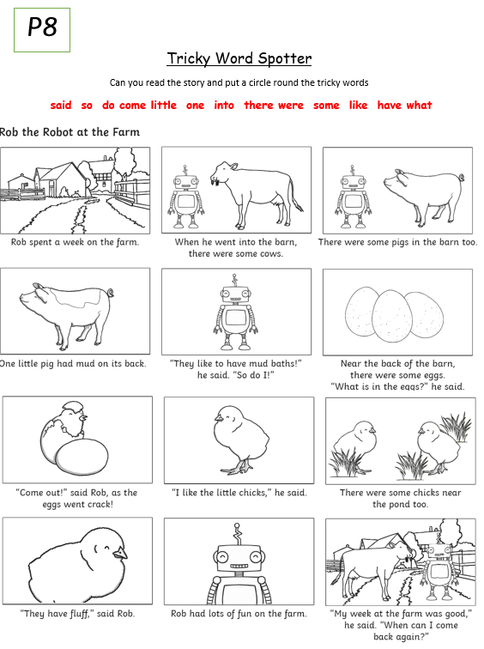
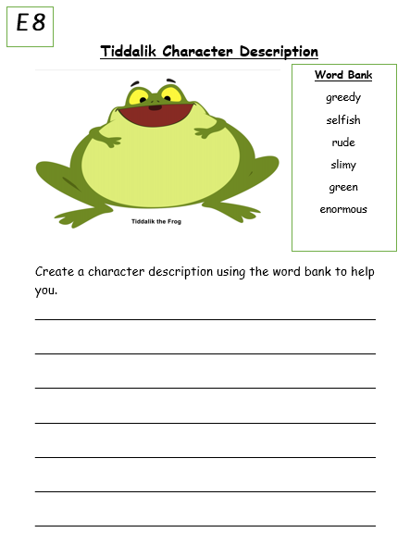
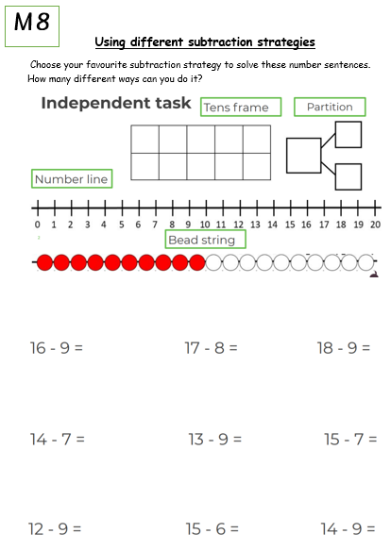
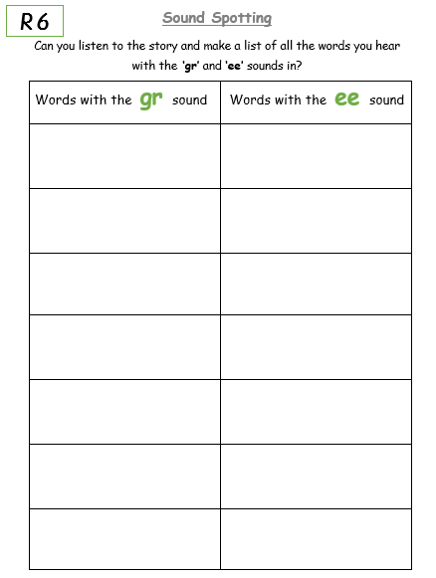
Day 4
Phonics
Today we are going to be looking at the tricky words in phase 5. Click on the link to watch todays video https://central.espresso.co.uk/espresso/primary_uk/subject/module/video/item97401/gradef/module63425/index.html
You might need to log in to Espresso using the log in below:

Username: student18029
Password: nwi123
After watching, the video find worksheet P9 in your learning pack. Can you read and spell the tricky words? Can you verbally put them into a sentence?

English
Today in English you are going to watch part 2 of Tiddalik. Click on the link below https://www.bbc.co.uk/teach/school-radio/english-ks1-tiddalik-the-frog-part-2/z6hmwty
In the story the animals plan to get the water back from Tiddalik and invite him to a celebration. Today you are going to create your own invitation for Tiddalik. Think carefully about the type of information you need to include on an invite.
Find worksheet E9 in your learning pack.
Maths
Today in maths, we are going to be practising our adding by using the counting on strategy.
Click the BBC link and take the quiz to practise your mental addition. https://www.bbc.co.uk/bitesize/articles/zbpbrj6
Next find worksheet M9 in your learning pack and use the counting on method to solve your addition number sentences.
Reading
Follow the link to the Oxford Owl reading site. https://www.oxfordowl.co.uk/
You will find the class login for Oxford Owl in your online login books which will explain how to access the texts.
Choose a text which matches the coloured book band you are on and then complete the activities from your book.
Topic- Science
Today we are continuing our learning on materials. What have you learnt so far? First, you are going to watch the story video of the three little pigs. Whilst you are watching it think about what materials the pigs houses are made out of and which would be strongest and why. Click on the link to watch the video.
https://central.espresso.co.uk/espresso/primary_uk/subject/module/video/item340600/grade1/module1128907/index.html
You may need to login to Espresso.
Once you have watched the video find worksheet S1 in your learning pack.
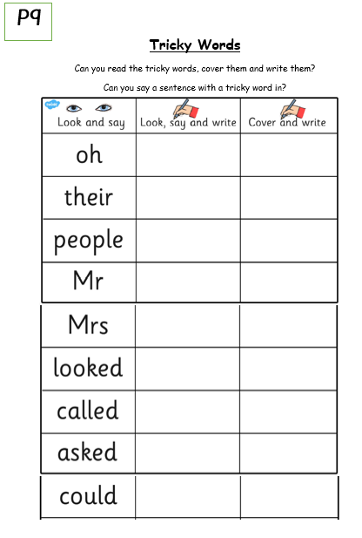
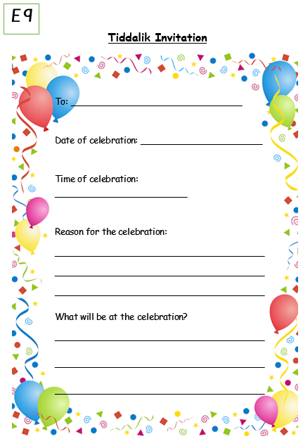
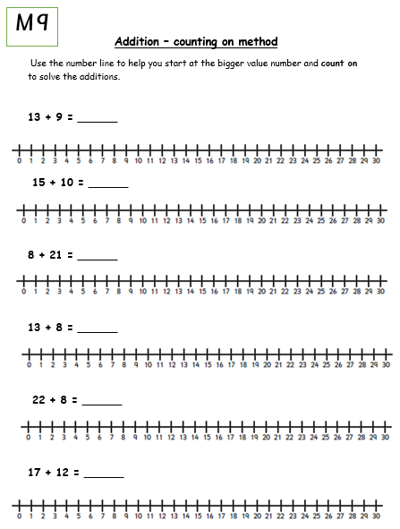
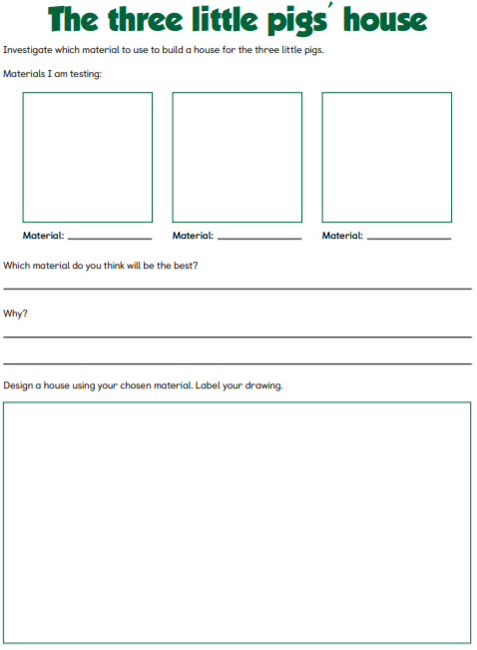
S1
Day 5
Phonics
Today you will practise the tricky words you have learnt this week.
Click on the link to access the phonics play tricky word truck game
https://www.phonicsplay.co.uk/resources/phase/2/tricky-word-trucks
You may need to login using these details
Username: whitefield123
Password: apple123
Have a practise reading the tricky words from each phase. Can you remember all of them? Have a look at worksheet P10. Get an adult to test you on the spelling of these words.
English
Today we are going to retell the story of Tiddalik. If you need to refresh your memory watch the story again at https://www.bbc.co.uk/teach/school-radio/english-ks1-tiddalik-the-frog-part-2/z6hmwty
Find worksheet E10 in your learning packs. Look at the pictures from the story and write a cation about each one. Try challenging yourself by using the time connectives first, then, after that and finally to start each caption. When you have finished retell your story to an adult.
Maths
Today in maths, we are going to be practising our subtraction by using the counting back strategy.
Click the link to watch todays lesson
https://www.google.com/search?q=subtraction+using+a+numberline+video&rlz=1C1GCEU_enGB859GB884&oq=subtraction+using+a+numberline+video+&aqs=chrome..69i57j0i22i30i457.7366j1j15&sourceid=chrome&ie=UTF-8#kpvalbx=_XxcLYP-iEsGX8gKfrZO4BQ9
Next find worksheet M10 in your learning pack and use the counting back method to solve your subtraction number sentences.
Reading
Follow the link to the Oxford Owl reading site. https://www.oxfordowl.co.uk/
You will find the class login for Oxford Owl in your online login books which will explain how to access the texts.
Choose a text which matches the coloured book band you are on and then complete the activities from your book.
Topic- E safety
It is extremely important that we know how to keep ourselves safe online. Watch the video on safety and what to do if something makes us worried online
https://www.stjamescebournemouth.com/e-safety-information/
Can you create a poster or leaflet all about how we can keep ourselves safe on the internet?


