Anansi and the Moss Covered Rock
E5
Can you cut the pictures out and sequence them in the right order on the next page? Can you retell the story to a grown up?
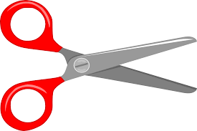
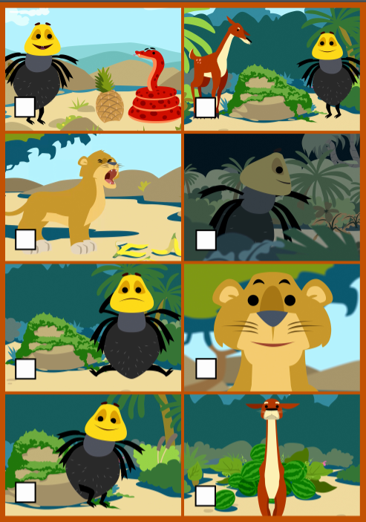

Cut out the story pictures and put them in the right order
1 | 2
3 | 4
5 | 6
7 | 8
E5 continued

