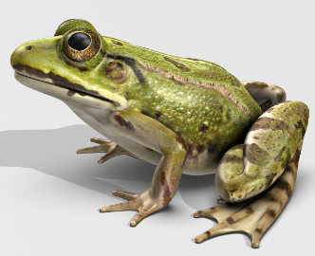
My Frog Fact File
E7
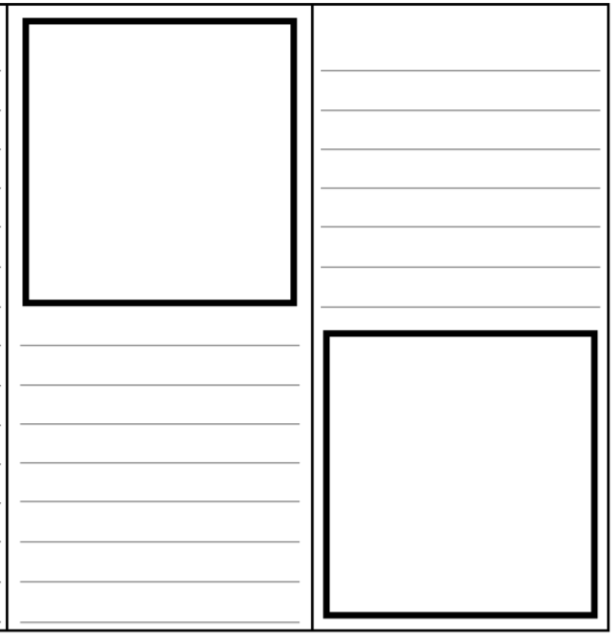
Use the information that you have learnt to create your own fact file.

