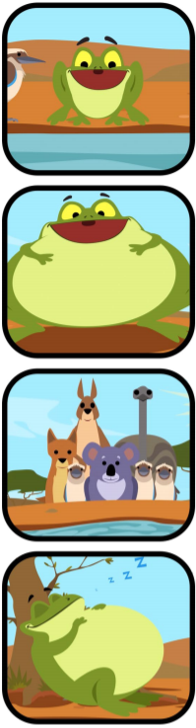
Tiddalik
E10
Write a caption to explain what is going on in each picture.
_____________________________________________________________________________________________________________________________________________________________________________________________________________________________________________________________________________________________________________________________________________________________

_____________________________________________________________________________________________________________________________________________________________________________________________________________________________________________________________________________________________________________________________________________________________

_____________________________________________________________________________________________________________________________________________________________________________________________________________________________________________________________________________________________________________________________________________________________

_____________________________________________________________________________________________________________________________________________________________________________________________________________________________________________________________________________________________________________________________________________________________

