Subtracting using number facts
M4
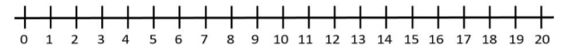
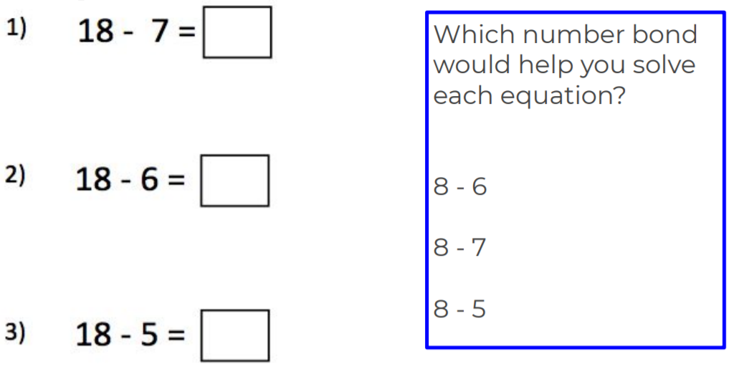
Look at the takeaway number sentences and use the number facts you already know to solve them.
Can you solve the rest of these? What number facts do you already know that can help you?
19 - 5 = ______
19 - 7 = ______
19 - 9 = ______

