Using different adding strategies
M7
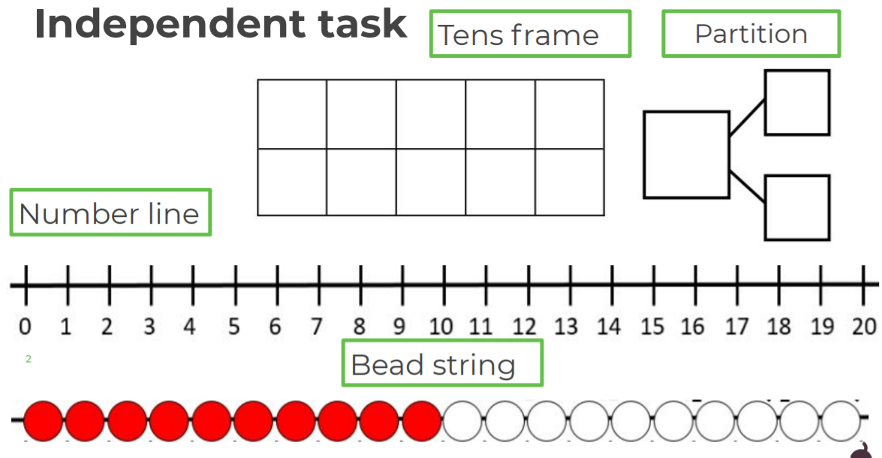
Choose your favourite adding strategy to solve these number sentences.

