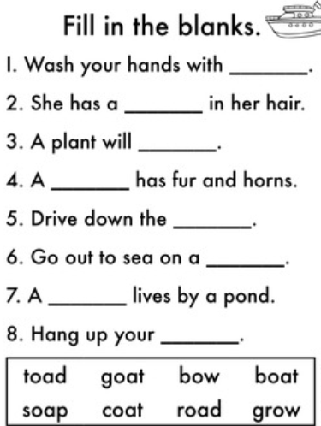
Can you put one of the words into your own sentence?
P4
_________________________________________________________________________________________________________________________________________________________

