Tricky Word Spotter
P8
Can you read the story and put a circle round the tricky words
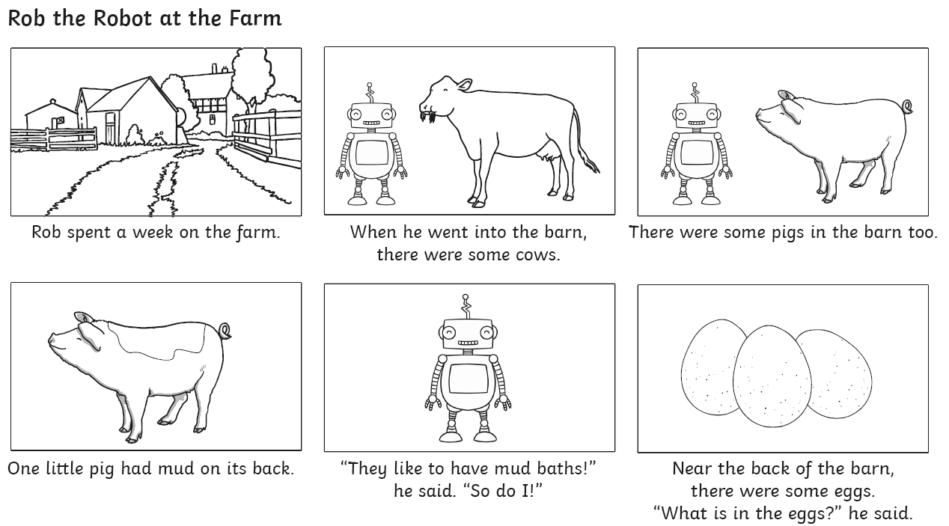
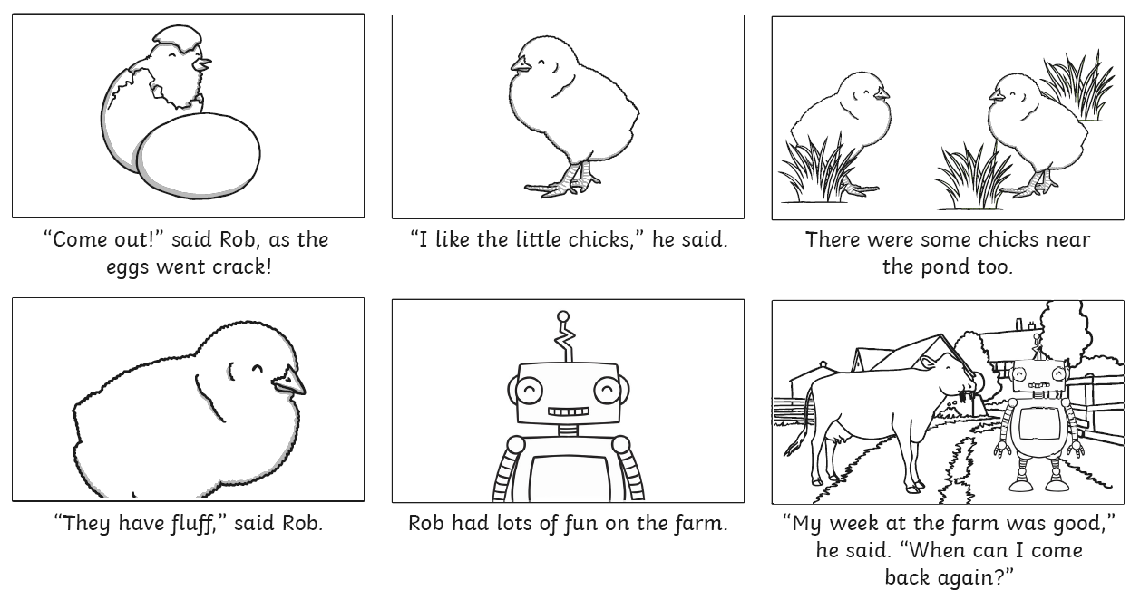
said so do come little one into there were some like have what

