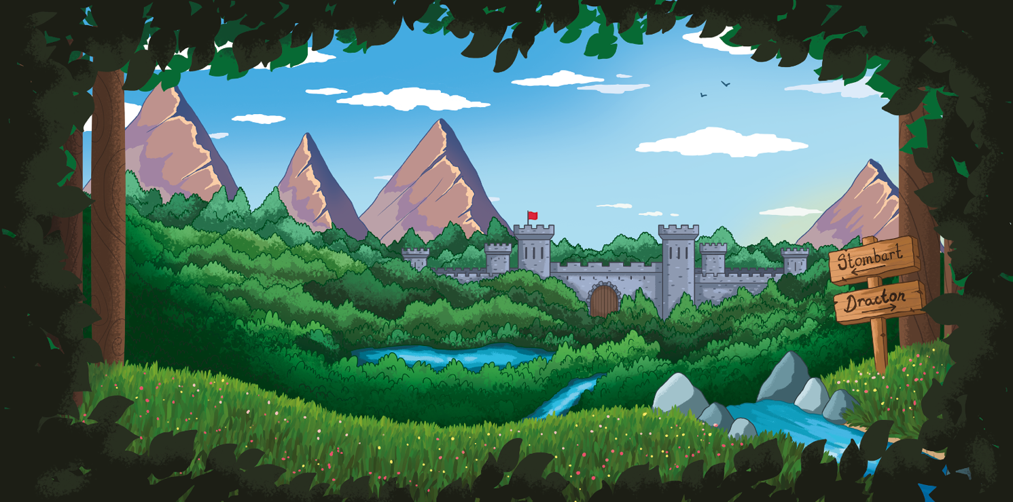
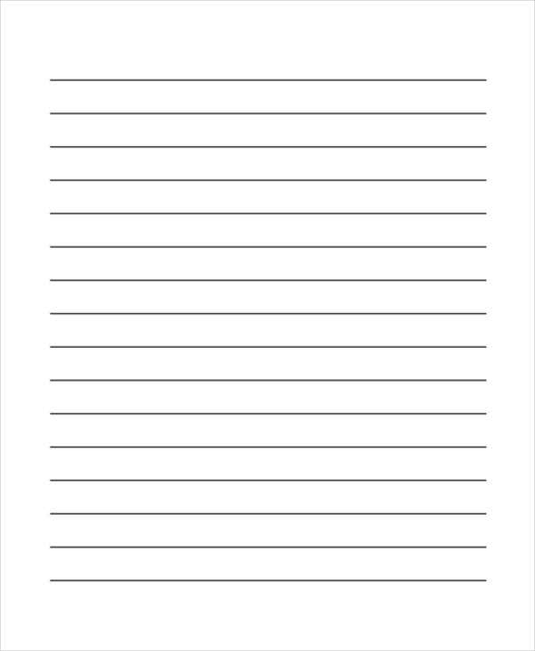
word bank

castle trees river mountains rocks grass

green towering winding stone blue leafy

