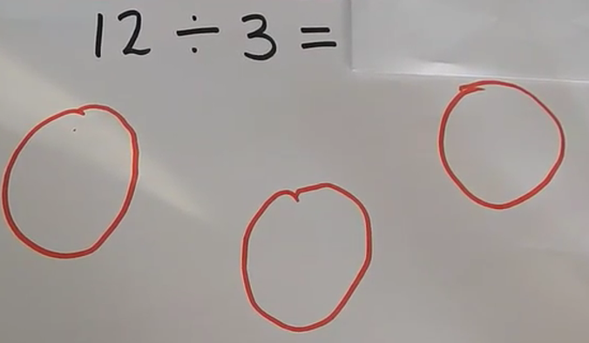
The amount to share
How many equal groups

Use your jottings to solve the division number sentences
8÷2=

10÷2=

12÷4=

9÷3=

16÷4=

