Alternate spellings for ‘or’
‘or’ ‘au’ ‘aw’
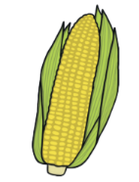
Use your phonics to write the correct grapheme for each word.
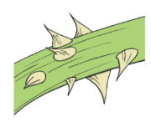
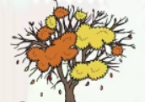


__tumn
c__n__n
th__n
h__nted

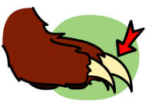
p__
cl__


l__nch
f__k
s__

Choose three words and write a sentence for each below.

- __________________________________________________________________________________________________________________________________________
- __________________________________________________________________________________________________________________________________________
- __________________________________________________________________________________________________________________________________________

