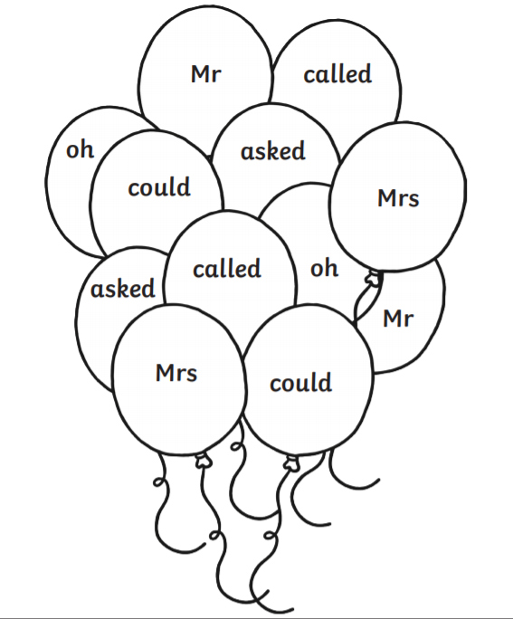
Read the high frequency words below and colour the balloons using the key.
I’m = red oh = blue called = purple their = green by = yellow old = pink
I’m
by
their
by
their
I’m
old
called
called
oh
old
oh

