Tiddalik Character Description
Word Bank
greedy
selfish
rude
slimy
green
huge

E8
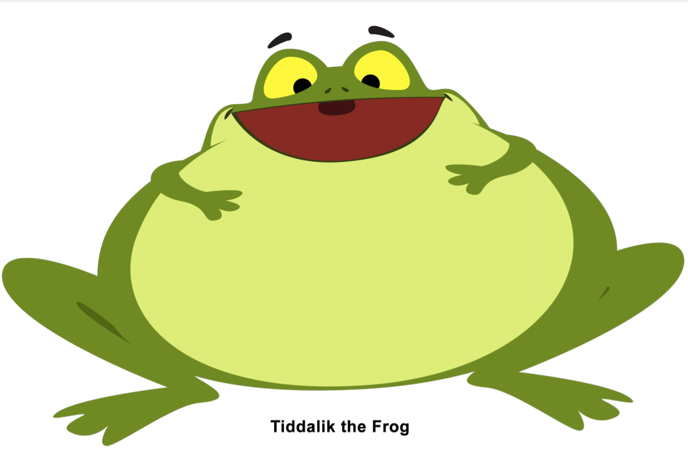

Create a character description using the word bank to help you. E,g He is green and slimy.
____________________________________________________________________________________________________________________________________________________________________________________________________________________________

