Draw some other yucky things that might be on Jack and Ma’s shelves in the kitchen.
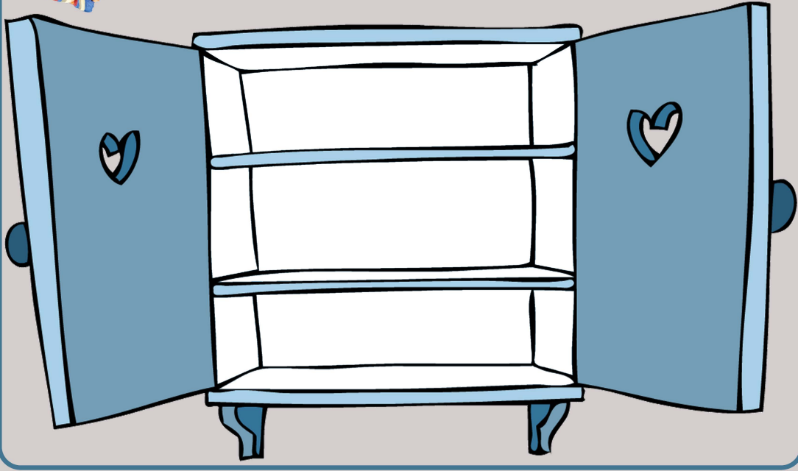
Now write a list of the items you have drawn.
Remember to use an adjectives to describe the noun. Smelly cheese.
__________________
__________________
__________________
__________________
__________________
__________________
__________________
__________________
__________________

