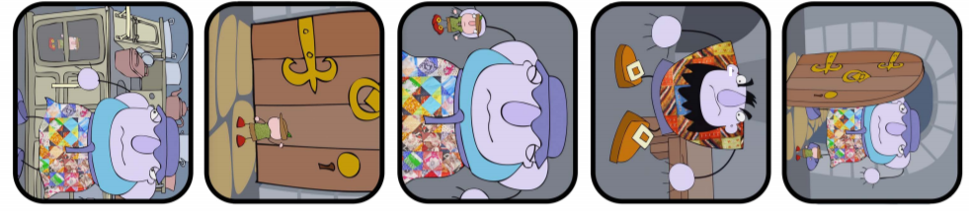
Write the numbers 1-5 in the circles to put the pictures in the correct order. Then write a sentence for each picture to help tell the story.
____________________________________________________________________________________________________________________________________________________
____________________________________________________________________________________________________________________________________________________
____________________________________________________________________________________________________________________________________________________
____________________________________________________________________________________________________________________________________________________
____________________________________________________________________________________________________________________________________________________

