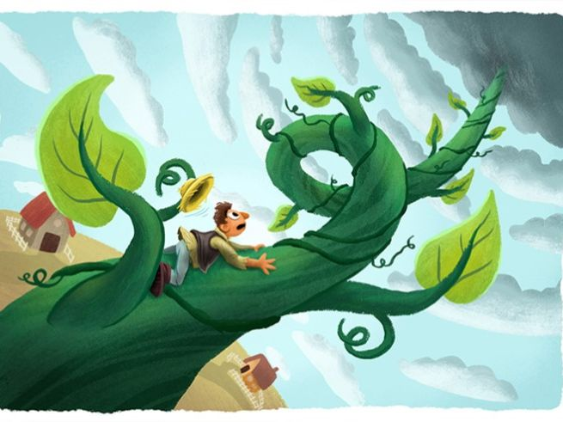

Adjectives | Nouns
fluffy  twisting  tiny  leafy  clear  birds  old  giant | clouds  vines  cottages  trees  skies  soaring  castle  boots

