Year Reception Week 1
Day 1
Phonics
Follow the link to the phonics lesson – in this lesson we will review the graphemes we already know and learn a new one ‘oo’.
https://www.youtube.com/watch?v=VQxqTmiDmIQ&ab_channel=LettersandSoundsforHomeandSchool

Follow the link to play the game. Use your phonics to carefully blend the words. Click Phase 3 – set 1-6
https://www.phonicsplay.co.uk/resources/phase/3/buried-treasure

Literacy

https://www.youtube.com/watch?v=sqQ1BAEj1oE&ab_channel=WideFrameUK
Follow the link to watch the story ‘The Naughty Bus’. Then have a go at re-telling the story.
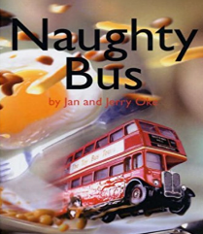
What happened at the beginning of the story, middle and end?

Ask your child to use their phonics and have a go at writing a simple
sentence about where the naughty bus went e.g. ‘The bus went in the pond’.
Remember your capital letters, finger spaces and full stops!

Maths
In this lesson we will be focussing on working out one more than a given number up to 10. Lesson 6 – Exploring one more within 10.

https://classroom.thenational.academy/lessons/exploring-one-more-within-10-74v3cc

If you do not have any objects to help you with counting at home don’t worry, you can still listen and join in.
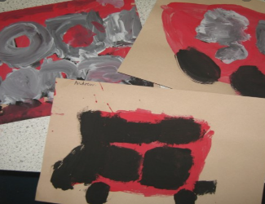
Topic- EAD –
Use paper and paints to paint the naughty bus –
can your child count out how many windows and doors to
add when painting the naughty bus?

Day 2

Phonics
Follow the link to the phonics lesson – in this lesson we will review the graphemes we already know and learn a new diagraph ‘ar.’
https://www.youtube.com/watch?v=yVsmYlNXU-k&ab_channel=LettersandSoundsforHomeandSchool

Follow the link to play the game. Use your phonics to carefully blend the words. Click Phase 3 – set 1-6
https://www.phonicsplay.co.uk/resources/phase/3/dragons-den

Literacy

https://www.youtube.com/watch?v=sqQ1BAEj1oE&ab_channel=WideFrameUK
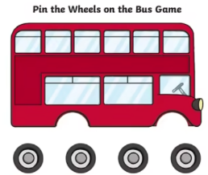
Follow the link to re-watch the story ‘The Naughty Bus’. Then have a go at re-telling
the story. What happened at the beginning of the story, middle and end?
Use the bus picture provided to cut out and add on the wheels on the bus.
Then have a go at labelling your naughty bus e.g. wheels, door, windows. Remember
to use your phonics!

https://www.twinkl.co.uk/resource/t-s-2618-new-pin-the-wheels-on-the-bus-game

Maths
In this lesson we will be focussing on one less than a given number up to 10– Lesson 7 – Exploring one less within 10.

https://classroom.thenational.academy/lessons/exploring-one-less-within-10-cgtk0c

Now complete the ‘one less’ worksheet.
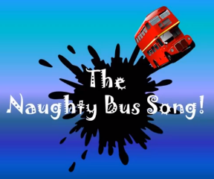
Topic- Music
Listen to the naughty bus song. Then have a go
at singing the song. Can you come up with actions and
perform the song in front of your family?

https://www.youtube.com/watch?v=jwYU3aQ3tHc&ab_channel=SingKids%21songsbySueBleazard

Day 3

Phonics
Follow the link to the phonics lesson – in this lesson we will review the digraphs we already know and learn a new one ‘or’.

https://www.youtube.com/watch?v=68FTaim0FOQ&ab_channel=LettersandSoundsforHomeandSchool

Follow the link to play the game ‘Phonics pop’. Click set 6- how many phoneme’s can you pop? Have a go…
https://www.ictgames.com/phonicsPop/

Literacy
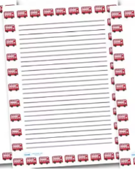
Can you remember what happened in the story ‘The Naughty Bus’. Think about your favourite part of the story and have a go at writing a simple sentence what happened e.g. The naughty bus made a big mess.

You can write it on any piece of paper – remember your
finger spaces and full stops children.
Use the writing frame provided.
https://www.twinkl.co.uk/resource/t-lp-506--red-bus-portrait-page-borders

Maths
Complete the missing numbers on the ‘Missing Number Ladder’ worksheet.
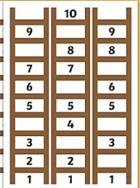
https://www.twinkl.co.uk/resource/t-n-1248-ladder-missing-number-to-10-worksheets

Topic- PD

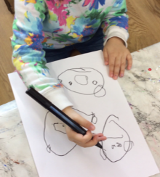
Use thick/ chunky felt tips – ask your child to draw and colour in their naughty bus. Does it look like the naughty bus from the story? Does it make a lot of mess just like it does in the story?

Day 4

Phonics
Follow the link to the phonics lesson – in this lesson we will review the digraphs we already know and learn a new one ‘ur’

https://www.youtube.com/watch?v=fbouFmTzBn8&ab_channel=LettersandSoundsforHomeandSchool
Follow the link to play the game. Use your phonics to carefully blend the words. Click Phase 3 – set 1-5

https://www.phonicsplay.co.uk/resources/phase/3/picnic-on-pluto

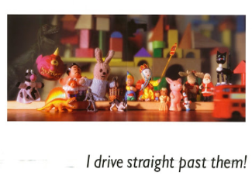
Literacy

Can your child re-tell the story of the Naughty Bus verbally?
Ask your child to write about how the characters on the bus stop
feel when the naughty bus drove straight past them e.g.
‘They feel sad and angry‘. Use the writing frame like you did
from yesterday.
Maths

In this lesson we will be placing numbers to 10 in the correct order- Lesson 8
https://classroom.thenational.academy/lessons/placing-numbers-within-ten-in-order-chgk8d

Then log on to ‘Busy Things’ and have a go at exploring and playing some counting games.

Topic- CAL/ EAD
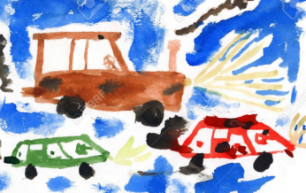
Choose a vehicle or transport and have a go at painting it or you can be as creative as you like! You could paint a bus, car, aeroplane, boat etc. Talk about the all the different vehicles and how they are similar and different.

Phonics
Follow the link to the phonics lesson – in this lesson we will review the digraphs we already know and learn a new one ‘ow’

https://www.youtube.com/watch?v=Et-E9brVTYE&ab_channel=LettersandSoundsforHomeandSchool

Follow the link to play the game. Use your phonics to carefully blend the words. Click on Phase 3- Set 1-6
https://www.phonicsplay.co.uk/resources/phase/3/buried-treasure

Literacy
Watch the story one more time this week!
https://www.youtube.com/watch?v=sqQ1BAEj1oE&ab_channel=WideFrameUK

Can your child join in with the story? No writing today children – oral retelling focus.

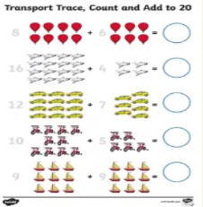
Maths
Complete the addition worksheet- counting up to 20.

https://www.twinkl.co.uk/resource/t-n-5118-transport-trace-count-and-add-to-20-worksheet

Topic-
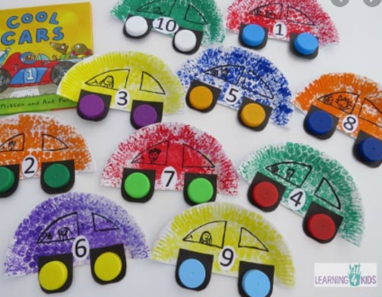

Using a paper plate have a go at making your own car.
You can decorate it however you like. Then have a go
at telling a journey your car went on. Where did your
car go on an adventure?

Day 5

Phonics
Follow the link to the phonics lesson – in this lesson we will review the digraphs we already know and learn a new one ‘oi’.

https://www.youtube.com/watch?v=iemIhNNSybw&ab_channel=LettersandSoundsforHomeandSchool

Follow this link to play the game. Use your phonic knowledge to carefully blend the words. Click on Phases 3- sets 6-7.

https://www.phonicsplay.co.uk/resources/phase/3/pick-a-picture

Literacy
Can you remember the story ‘The Naughty Bus’ from last week? What happens in the story? Listen to the story to recap what happens in the story.

https://www.youtube.com/watch?v=sqQ1BAEj1oE&ab_channel=WideFrameUK
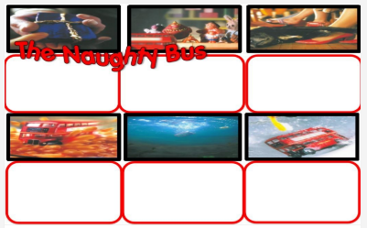
Use the resource sheet and have a go at writing a simple
sentence under the first 3 pictures (top row)
re-telling the story e.g. The boy got a present.
Remember to use your phonics to help you spell!
Don’t forget your finger spaces and full stops too.
Maths
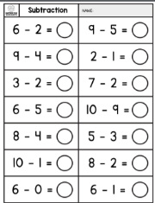
In this lesson we will be exploring subtraction up to 10. Lesson 3- Exploring subtraction as partitioning.
https://classroom.thenational.academy/lessons/exploring-subtraction-as-partitioning-6gv62c

Now complete the subtraction worksheet.
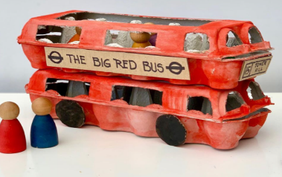
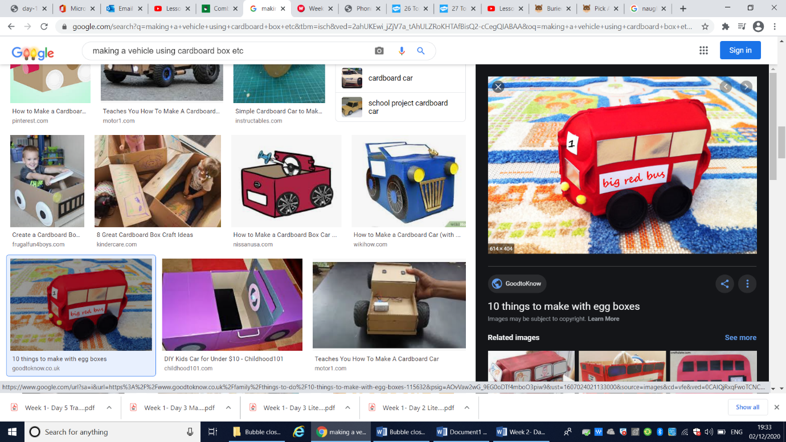
Topic- EAD/ DT

Use cardboard boxes, egg cartons and cardboard cylinders from kitchen roll to design and make a vehicle– Focus on joining skills e.g. what could we use to join? Sellotape, split pins/ masking tape etc/ whatever you can find in the house. Decorate your vehicle with milk top lids/ colour/ paint etc.

Week 2 - Day 1
Phonics
Follow the link to the phonics lesson – in this lesson we will review the digraphs we already know and learn a new one ‘ear’.
https://www.youtube.com/watch?v=9eIe4BHR4_s&ab_channel=LettersandSoundsforHomeandSchool

Follow this link to play the game. Use your phonic knowledge to carefully blend the words. Click on phase 3 – Digraphs
https://www.phonicsplay.co.uk/resources/phase/3/pick-a-picture

Literacy
Continue to complete writing simple sentences re-telling
the story ‘The Naughty Bus’. Complete the bottom row
of pictures. Don’t forget your finger spaces and full stops
children!

Maths

In this lesson we will be exploring subtraction as takeaway- Lesson 4
Click on the link below to view the lesson linked to subtraction.
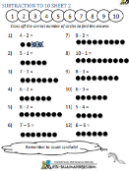
https://classroom.thenational.academy/lessons/exploring-subtraction-as-takeaway-ctj64r

Now complete the subtraction worksheet.
Don’t forget to cross out the circles!
Topic- EAD/Music
https://classroom.thenational.academy/lessons/sitting-on-the-bus-c4t64d

Follow the link to watch and join in with our music lesson all about transport and journeys. The song is called sitting on the bus.

Day 2

Day 3
Phonics
Follow the link to the phonics lesson – in this lesson we will review the phase 3 digraphs we already know and learn a new one ‘air’
https://www.youtube.com/watch?v=BOdSE-ATXI8&ab_channel=LettersandSoundsforHomeandSchool
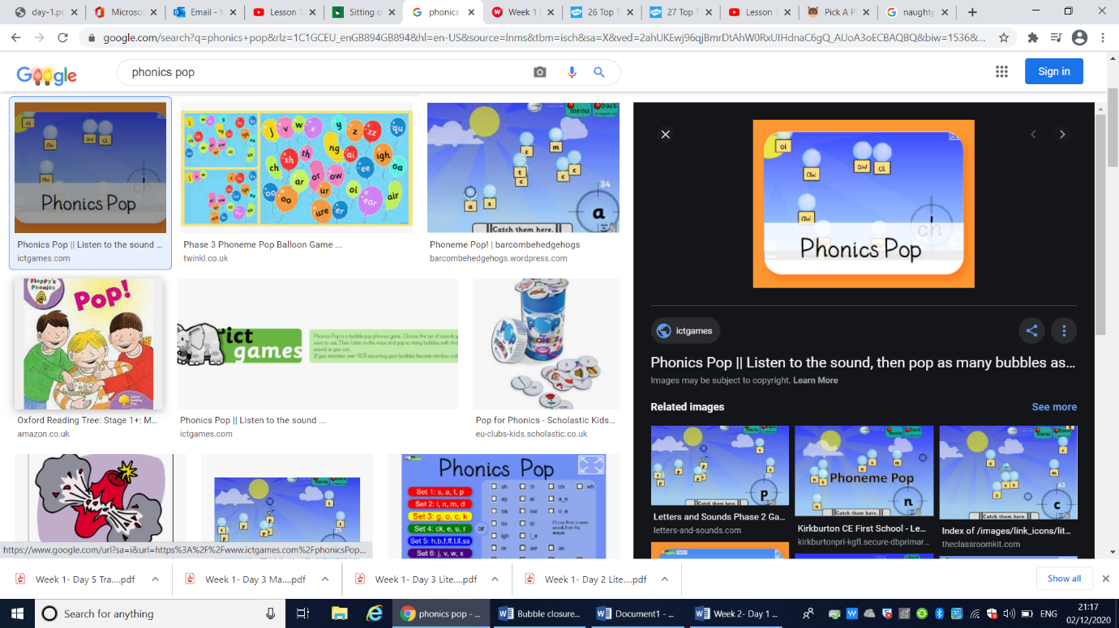
Follow the link to play the game ‘Phonics pop’.
Click set 7- how many phoneme’s can you pop? Have a go…
https://www.ictgames.com/phonicsPop/

Literacy

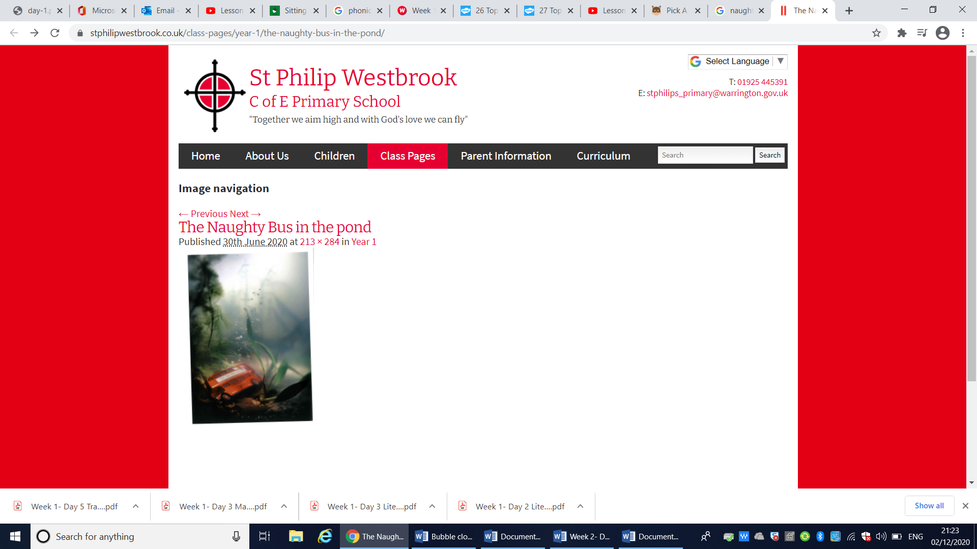
Use the speech bubble template to complete your writing task. Have a go at writing how the naughty bus felt when he fell in the pond.
Don’t worry if your child struggles to spell some words correctly –
the main thing is that they use their phonic knowledge – so it might
look like this ‘the notee bus woz sced”. Please encourage your child to
spell key words correctly e.g ‘the’.

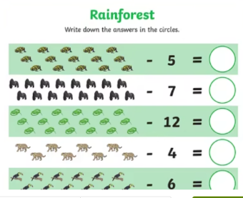
Maths

Complete the subtraction worksheet to 20.

https://www.twinkl.co.uk/resource/t-t-28792-rainforest-themed-subtraction-within-20-activity-sheet

Have a go at playing the subtraction game:
https://www.topmarks.co.uk/subtraction/subtraction-to-10

Topic- Music

https://classroom.thenational.academy/lessons/sailing-on-a-boat-6gwkjt

Click on the link to join in with our second online music lesson- Sailing on a boat!
Have a go at singing along- can you make up some actions?

Day 4

Phonics
Follow the link to the phonics lesson – in this lesson we will review the digraphs we already know and learn a new one ‘ure’
https://www.youtube.com/watch?v=dVau1GoS8wQ&ab_channel=LettersandSoundsforHomeandSchool

Follow this link to play the game. Use your phonic knowledge to carefully blend the words. Click on phase 3- set 1-7.
https://www.phonicsplay.co.uk/resources/phase/3/dragons-den

Literacy

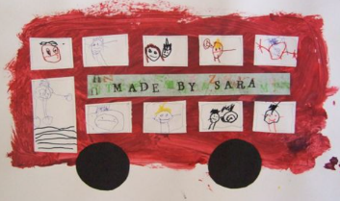
Design and draw your very own ‘Naughty Bus’. It can be any colour you like and even have some patterns on it! After designing it can you write a simple sentence to describe your bus? Have a go and remember your finger spaces and full stops. You might write ‘My bus goes really fast and is friendly’.

Use the template provided.

Maths

In this lesson we will be comparing 2 sets of objects using more or fewer- Lesson 5

https://classroom.thenational.academy/lessons/comparing-2-sets-of-objects-using-more-or-fewer-75k62t

Recap playing the subtraction game that you played yesterday- click on the link below:
https://www.topmarks.co.uk/subtraction/subtraction-to-10

Topic- UW
Follow the link to learn all about transport and vehicles – Transport model
https://classroom.thenational.academy/lessons/transport-model-60wpat

Have fun making an aeroplane! Can you describe what it looks like and what it needs to fly high in the sky?

Day 5

Phonics
Follow the link to the phonics lesson – in this lesson we will review the digraphs we already know and learn a new one ‘er’.
https://www.youtube.com/watch?v=avg7f4o6Zb0&ab_channel=LettersandSoundsforHomeandSchool

Follow this link to recap and play the game. Use your phonic knowledge to carefully blend the words. Click on phase 3 digraphs

https://www.phonicsplay.co.uk/resources/phase/2/pick-a-picture

Literacy
Use the writing frame – Child to write a letter to the little boy in the
story (pretending to be the naughty bus). Write simple sentences
e.g. ‘I am sorry’ ‘I was bad’, I made a big mess, ‘Please forgive me’ etc.

https://www.twinkl.co.uk/resource/t-lp-506--red-bus-portrait-page-borders

Maths
In this lesson we will be investigating quantities using more or fewer.

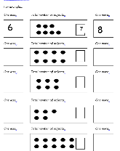
https://classroom.thenational.academy/lessons/investigating-quantities-using-more-or-fewer-cmwp6d

Now complete the ‘one more one less’ worksheet.

Topic – UW

Think about all the different vehicles, can you name some? Follow the link below- it explains features of different modes of transport.

https://classroom.thenational.academy/lessons/to-explain-features-of-different-modes-of-transport-chjk0c

