Year 1 Week 1
Day 1
Phonics
Today in phonics you are going to be learning all about the ‘or’ sound and the alternative spellings.
Click the link and watch the video all about ‘au’ and ‘aw’.

https://www.youtube.com/watch?v=GHpyJ5svbgM

Find worksheet P1 in your workbook and complete the activity.

English
In your English lessons this week, you will be using the ‘Knights and Dragons Unite’ text.
Today, you are going to write a prediction for what you think will happen in the story and why, using the front cover.

Find worksheet E1 in your workbook and complete the task.

Maths
This week in maths we are going to be learning about division. Today we are going to start with finding half of an even number. Click on the link and watch the short video explaining how to find half by sharing into 2 equal groups.

https://www.whitefield-inf.lancs.sch.uk/division/

Then find worksheet M1 in your workbook and complete the task.
Reading
Follow the link to the Oxford Owl reading website https://www.oxfordowl.co.uk/

You will find the class login for Oxford Owl in your online login books which will explain how to access the texts. Choose a text which matches the coloured book band you are on.

Find worksheet R1 in your workbook. Draw a picture of your favourite part of the book and write some sentences to explain why.
Topic – Computing
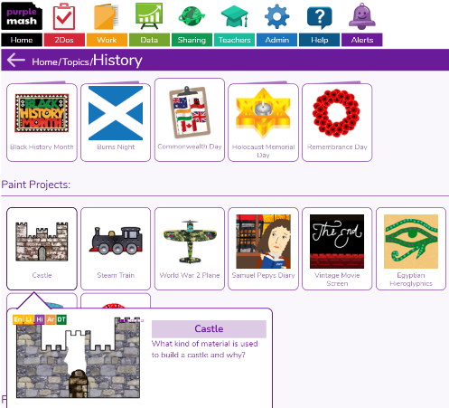
Today you are going to practise you’re mouse skills. Click on the link and use the mouse to fill in the castle template.
https://www.purplemash.com/#tab/pm-home/topics/history

Think carefully about what materials are used to build a castle.

Day 2
Phonics
Today in phonics you are going to be learning all about the ‘f’ sound and the alternative spelling.
Click the link and watch the video all about ‘ph’ alternate spelling.

https://www.youtube.com/watch?v=b6Keu6eiptc

Then find worksheet P2 in your workbook and complete the activity.

English
Today, you are going to write questions about what you want to find out in the story using the front cover. Follow the link to watch a video about ‘How to write questions’ https://www.bbc.co.uk/bitesize/topics/zrqqtfr/articles/z2xdng8

Find worksheet E2 in your workbook and complete the task. Remember to use the question hand resource to help write your questions.

Who is the dragon? How did they get there? What is the name of the castle?

Maths
Today in maths we are going to be learning about dividing by sharing into equal amount. Click on the link and watch the short video explaining how to divide by sharing into equal groups.

https://www.whitefield-inf.lancs.sch.uk/division/

Find worksheet M2 in your workbook and complete today’s activities.

Reading
Follow the link to listen to the ‘A Monster Surprise’ story
https://www.youtube.com/watch?v=Qe7G_ipEukU
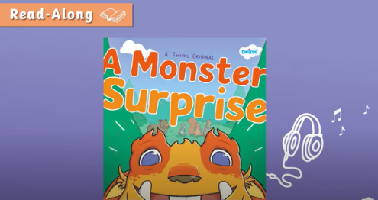

Find worksheet R2 in your workbook and complete the character description for the monster. Remember to use the word bank to help write your sentences.

Topic - PE
Today in PE you are going to be going ‘Into the Wild’ for a movement lesson. You are going to be learning about different ways to travel and jump. You will need to make sure you have a big clear space for your PE lesson today.

https://www.youtube.com/watch?v=DtfvUedMTDA

I wonder what animals you will find in the wild.

Day 3
Phonics
Today in phonics you are going to be learning all about the ‘w’ sound and the alternative spelling.
Click the link and watch the video all about ‘wh’ alternate spelling.
https://www.youtube.com/watch?v=mppiO8xtYoA

Then find worksheet P3 in your workbook and complete the activity.
English
Today, you are going to write a setting description using a picture from the book.
Find worksheet E3 in your workbook and complete the task. Remember to use the word bank to help write your sentences.

There is a stone castle hidden in the leafy trees.
A blue, winding river runs past the large rocks.

Maths
Today you are going to continue your learning on dividing by sharing into equal groups.
Click on the link and re- watch the video from yesterday to refresh your mind.
https://www.whitefield-inf.lancs.sch.uk/division/

Today you are going to draw your own groups and share the amount equally. Find worksheet M3 in your workbook and complete today’s activities.
Reading
Follow the link to listen to the ‘A Monster Surprise’ story
https://www.youtube.com/watch?v=Qe7G_ipEukU

Find worksheet R3 in your workbook and complete the reading comprehension. An adult will need to help you read the questions.
Topic- History
Today in history we are going to be learning all about the parts of a castle. Have you seen a castle before?
Now click the link and watch the video all about the parts of the castle. https://www.youtube.com/watch?v=ZZtWmElqPpU
Find worksheet T1 in your workbook and label the castle using the glossary below.
Arrow loops – Slim opening inside the walls for archers to fire arrows.
Bailey – This is a courtyard inside the outer wall of the castle.
Barbican – This is a fortified gateway which is near a gate or bridge and is used to defend the castle.
Battlements – A wall around the top of the castle with square spaces for people in the castle to shoot through.
Drawbridge – A bridge that can be lowered and raised.
Moat – A deep ditch filled with water to protect the castle.
Portcullis – A strong metal gate that can be lowered to protect the castle from enemies.
Tower – A tall narrow building that stands alone or as part of the castle.

Day 4
Phonics
Today you are going to be learning about the alternate spelling for the ‘ow’ sound. Click the link and watch the video for today’s lesson off ‘Mr Thorne’

https://www.youtube.com/watch?v=z9NqcU6ccz0

Now find worksheet P4 in your workbook and complete the activity.

English
Today, you are going to write a character description for Aristar the dragon. Follow the link to listen to the story and pause it at 0.54 seconds https://www.youtube.com/watch?v=hOcCl0jKwvU
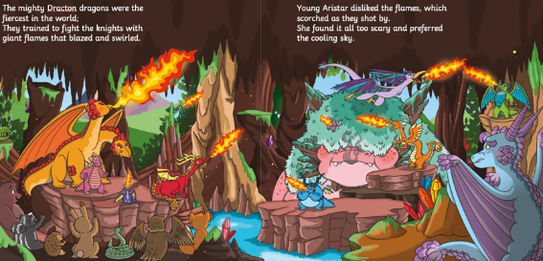
Find worksheet E4 in your workbook and complete the task. Remember to use your word bank to help write your sentences.

Aristar the dragon has large wings to help him fly and pointy horns on his head.

Maths
Today you are going to learn about dividing by making equal groups. Click on the link to watch the short video explaining how to divide by grouping.

https://www.whitefield-inf.lancs.sch.uk/division/

After watching the video, find worksheet M4 in your workbook and complete the division sums.
Reading
Follow the link to listen to the ‘A Monster Surprise’ story

https://www.youtube.com/watch?v=Qe7G_ipEukU

Find worksheet R4 in your workbook and complete the story sequencing map. Think carefully about the order of the events that took place. You will need a pair of scissors and a glue stick. If you don’t have them at home don’t worry you can draw the pictures yourself to sequence the story.

Topic- Science
Today in science you are going to continue your learning about materials. Today you are going to learn about the properties of materials and if they are suitable. Click on the link and watch the video.
https://central.espresso.co.uk/espresso/primary_uk/subject/module/video/item1134428/grade1/module1128907/index.html

You may need to login to discovery espresso using the details below.
Username: student18029
Password: nwi123

After watching the video you are doing to test some materials to see if they are absorbent. Find worksheet T2 in you workbook and complete your investigation.

Day 5
Phonics
Today you are going to be learning about the alternate spelling for the ‘oo’ sound. Click the link and watch the video for today’s lesson off ‘Mr Thorne’

https://www.youtube.com/watch?v=GJL84QOnGIA

Now find worksheet P5 in your workbook and complete the activity.

English
Today, you are going to rewrite the opening part of the story. Follow the link to listen to the story and pause it at 1.12 minutes https://www.youtube.com/watch?v=hOcCl0jKwvU
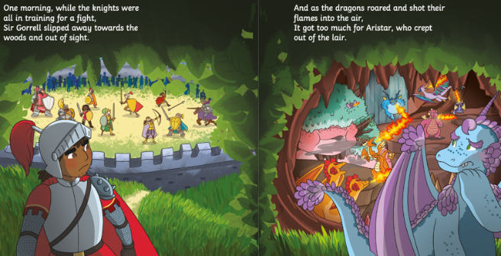
Find worksheet E5 in your workbook and complete the task. Remember to use your word bank to help write your sentences.

One morning, the knights are training for a fight at the castle. They have swords and shields but Sir Gorell does not like to fight. He does good deeds instead. The dragons live in a lair. A dragon called Aristar does not like the flames and gets scared. Sir Gorell and Aristar leave to go to the woods.

Maths
Today you are going to continue learning about dividing by making equal groups. Click on the link to watch the short video to refresh your memory on how to divide by grouping.

https://www.whitefield-inf.lancs.sch.uk/division/

Then find worksheet M5 in your workbook and complete the activities.

Reading
Follow the link to listen to the ‘A Monster Surprise’ story
https://www.youtube.com/watch?v=Qe7G_ipEukU

Find worksheet R5 in your workbook and complete the diary entry by the monster. Remember to use the word bank to help write your sentences. Think carefully about the order of the events that took place.

Topic- PSHE
Today you are going to be learning about ‘Living in the wider world’
Click the link and watch the lesson about ‘Local Heroes’ https://classroom.thenational.academy/lessons/local-heroes-cmw66c

Then find worksheet T3 in your workbook and draw a picture of a local hero you might see in Nelson and write some sentences about what they do and how they might care or protect you.
Year 1 Week 2
Day 1
Phonics
Today you are going to be learning about the alternate spelling for the ‘er’ sound. Click the link and watch the video for today’s lesson off ‘Mr Thorne’

https://www.youtube.com/watch?v=pV_ga8RGZFU

Now find worksheet P6 in your workbook and complete the activity.

English
This week we are continuing our learning with the story ‘Knights and Dragons Unite.’
Today, you are going to write a prediction for what you think is going to happen next in the story.

Follow the link to listen to the story https://www.youtube.com/watch?v=hOcCl0jKwvU
pause the video at 1:25 minutes.

Find worksheet E6 in your workbook and complete the task.

Maths
This week in maths you are going to be learning about time.
Today you are going to begin learning reading and writing the time to o’clock. Click on the link to watch today’s lesson.
https://classroom.thenational.academy/lessons/reading-and-writing-the-time-to-oclock-part-1-69jk6t
Then find worksheet M6 in your workbook, read the clocks and write the correct time.

Reading
Follow the link to the Oxford Owl reading website https://www.oxfordowl.co.uk/

You will find the class login for Oxford Owl in your online login books which will explain how to access the texts. Choose a text which matches the coloured book band you are on.

Find worksheet R6 in your workbook. Draw a picture of your favourite character from the book and write some sentences to explain why.

Topic- Design technology
This week in design technology we are going to be designing and making a healthy fruit salad.
Today you will think about fruits that you like and dislike and then you will design your fruit salad.

Find worksheet T4 in your workbook and complete the task.

Day 2
Phonics
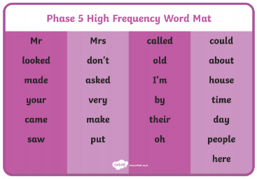
For the rest of the week in phonics we are going to looking at phase 5 high frequency words.

Find worksheet P7 in your workbook and complete the task.
English
Today, you are going to write some thought bubbles to show what the characters are thinking. Follow the link to listen to the story and pause it at 2.03 minutes https://www.youtube.com/watch?v=hOcCl0jKwvU
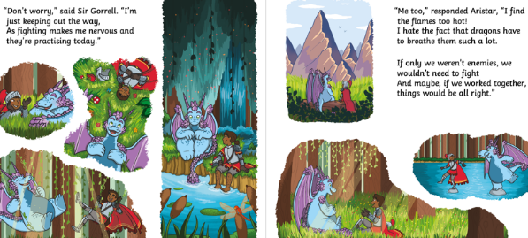

Find worksheet E7 in your workbook and complete the task.

I feel nervous about the flames.
I wonder if we can be friends.

Maths
Today you are going to continue learning to read and write the time to o’clock.
Click on the link to watch today’s lesson.
https://classroom.thenational.academy/lessons/reading-and-writing-the-time-to-oclock-part-2-cnj6ar
Then find worksheet M7 in your workbook, today you are going to draw the minute and hour hands on the clock to show the correct time. To help you, you could use a blue pencil for the minute hand and a red pencil for the hour hand.
Reading
Follow the link to listen to the ‘Knights and Dragons Unite’ story https://www.youtube.com/watch?v=hOcCl0jKwvU

Find worksheet R7 in your workbook and complete the reading comprehension. An adult will need to help you read the questions.

Topic- Design Technology

Today you are going to make the fruit salad that you previously designed, taste it and evaluate it.
Find worksheet T5 in your workbook and follow the instructions to make your healthy fruit salad.

Remember to take a picture and send it to your teacher and tell them what you liked, if there was anything you didn’t like, if you made it again what would you change.

Day 3
Phonics
Today we are going to continue looking at phase 5 high frequency words.

Find worksheet P8 in your workbook and complete the task.
English
Today, you are going to create an invitation for the talent show. Follow the link to listen to the story and pause it at 2.29 minutes https://www.youtube.com/watch?v=hOcCl0jKwvU
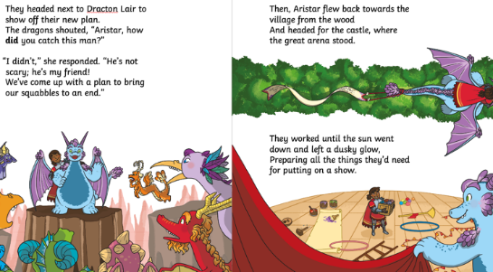

Find worksheet E8 in your workbook and complete the task.

Maths
For today’s maths lesson you are going to begin to learn how to read and write the clock to o’clock and half past.
Click on the link to watch today’s lesson.
https://classroom.thenational.academy/lessons/reading-and-writing-the-time-to-oclock-and-half-past-part-1-6wwpat
Now find worksheet M8 in your workbook, read the clocks and write the correct times.

Reading

Follow the link to listen to the ‘Knights and Dragons Unite’ story https://www.youtube.com/watch?v=hOcCl0jKwvU

Find worksheet R8 in your workbook and complete the story sequencing map. Think carefully about the order of the events that took place. You will need a pair of scissors and a glue stick. If you do not have these at home, don’t worry you can draw the pictures yourself to sequence the story.

Topic- P.E
Today in PE you are going to be going ‘Under the Sea’ for a movement lesson. You are going to be learning about different ways to travel and roll. You will need to make sure you have a big clear space for your PE lesson today.

https://www.youtube.com/watch?v=a78-VKcdNNc

I wonder animals you will find in the ocean!

Day 4
Phonics
Today we are going to continue looking at phase 5 high frequency words.

Find worksheet P9 in your workbook and complete the task.

English

Today, you are going to write a list of things that they will need for the talent show. Follow the link to listen to the story and pause it at 3.34 minutes https://www.youtube.com/watch?v=hOcCl0jKwvU
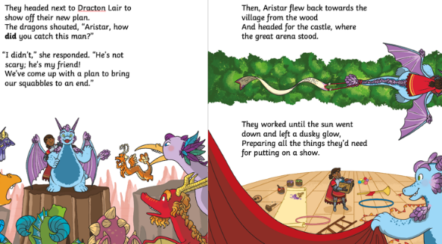

Find worksheet E9 in your workbook and complete the task. Remember to use your word bank to help write your list.

Maths
Today in maths you are going to continue learning to read and write the time to o’clock and half past.
Click on the link to watch today’s lesson.
https://classroom.thenational.academy/lessons/reading-and-writing-the-time-to-oclock-and-half-past-part-2-c4wkjr
Then find worksheet M9 in your workbook and write the time each clock shows.

Reading
Follow the link to listen to the ‘Knights and Dragons Unite’ story https://www.youtube.com/watch?v=hOcCl0jKwvU

Find worksheet R9 in your workbook and complete the book review. Think carefully about what you liked or disliked about the story and why. Who was your favourite character? Why? Is there anything you would change about the story?

Topic- History
In your history learning today you are going to be learning about Knights and their armour.

You will find the PowerPoint on the remote learning webpage of your class page.

Find worksheet T6 in your workbook and read all about the different parts of a Knights armour and then label the different parts on your worksheet.

Day 5
Phonics
Today we are going to continue looking at phase 5 high frequency words.

Find worksheet P10 in your workbook and complete the task.

English
Today, you are going to write a rhyming poem about a knight. Follow the link to listen to the rest of the story https://www.youtube.com/watch?v=hOcCl0jKwvU
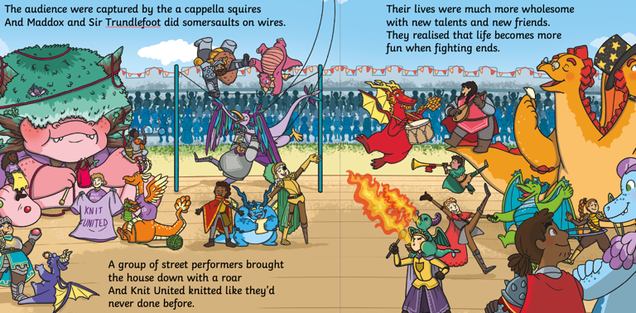
Find worksheet E10 in your workbook and complete the poem. Remember to use your word bank to complete the poem and make it rhyme.

Rhyming words are words that sound the same:
cat, bat, sat, mat, rat

Maths
In today’s maths lesson you are going to learn to read and write the time to o’clock and half past in words.
Click on the link to watch today’s lesson.
https://classroom.thenational.academy/lessons/reading-and-writing-the-time-to-oclock-and-half-past-in-words-6xj3ac
After watching the lesson find worksheet M10 in your workbook and write what time each clock shows in words.
Reading
Follow the link to listen to the ‘Knights and Dragons Unite’ story https://www.youtube.com/watch?v=hOcCl0jKwvU

Find worksheet R10 in your workbook and write some sentences about what Aristar and Sir Gorrell did next.

Topic- Outdoor learning
Today you are going to be making a simple bird feeder. You can hang this outside and encourage the birds to come. I wonder what birds come and feed on your feeder. The best time to catch them is in a morning.

Click on the link and watch the video about birds. https://central.espresso.co.uk/espresso/primary_uk/subject/news/video/item765757/grade1/index.html?source=search-all-KS1-all-all&source-keywords=birds

Find worksheet T7 in your workbook for instructions on how to make a bird feeder.

