
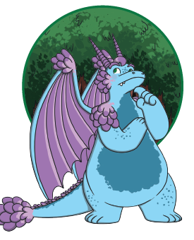
Look at the words and phrases that describe Aristar the dragon. Can you add any of your own?
scaly
giant
purple
pointy horns
large wings
sharp claws

