
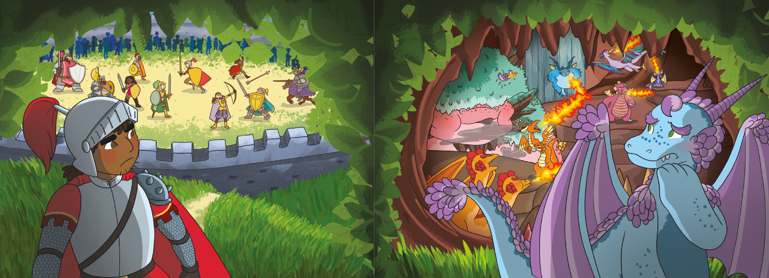
word bank

One morning, knight dragon castle lair fight

Sir Gorell Aristar flames swords shields scared

