The amount to share
How many in each group
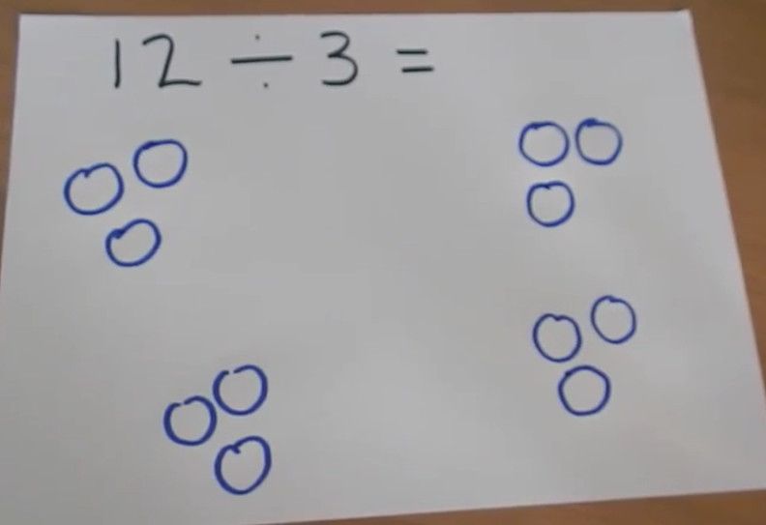

Use your jottings to solve the division number sentences
8÷2=

10÷5=

16÷4=

9÷3=

20÷4=

