Draw the hands on the clock to show the time.
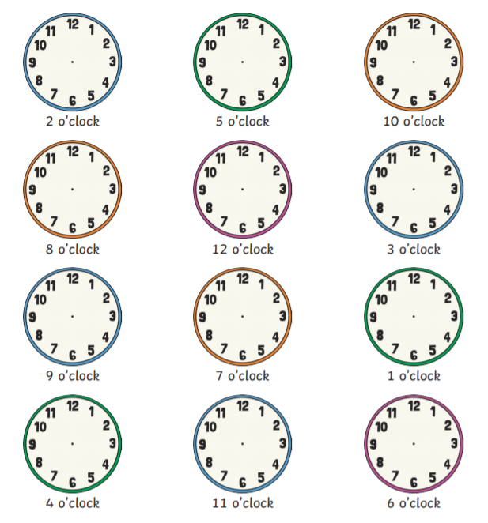
Remember the short hand shows the hour and the long hand shows the minutes. Try to point the hands as accurately as you can.

