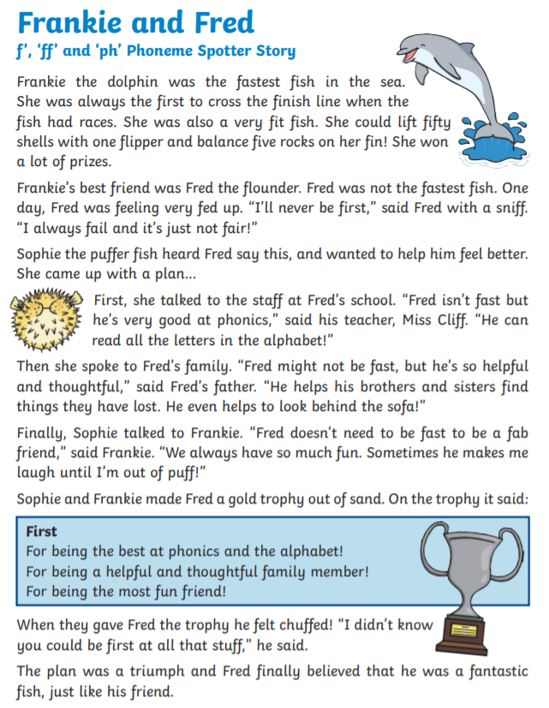
Read the story and circle all the words with the ‘f’ ‘ff’ and ‘ph’ sound.

Choose 2 words from the story and write your own sentence.
____________________________________________________________________________________________________________________________________________________________________________________________________________________________________________________________________________________________________________________________________________________________

