Alternate spellings ‘er’ ‘ur’ ‘ir’
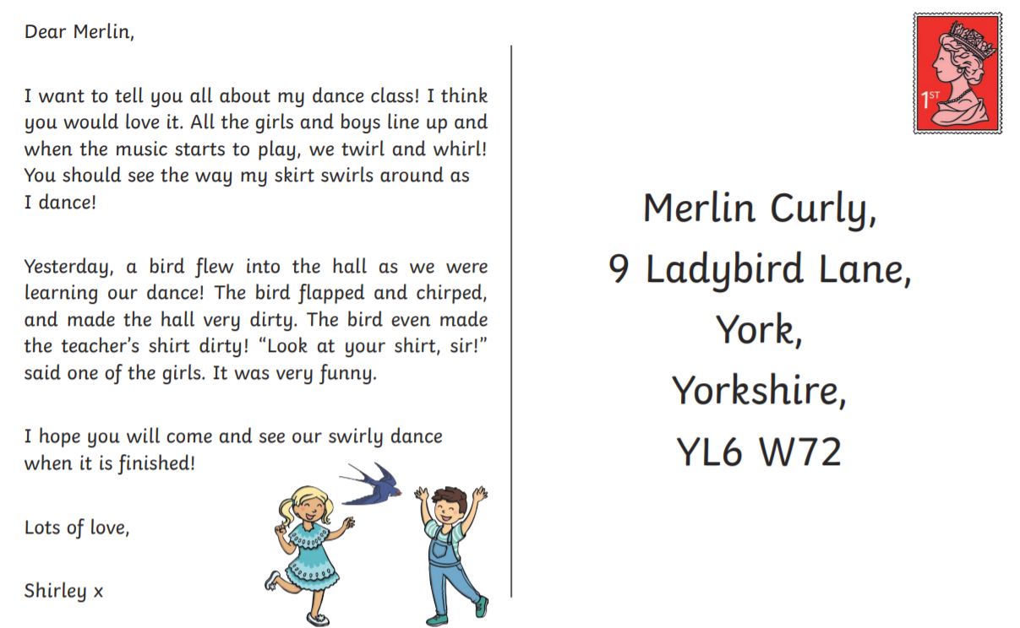
Read the postcard and circle all the words with the ‘er, ur and ir’ spellings.

Read the caption and draw a picture to show what is says.
The little girl with curly hair was eating a burger and fries.

