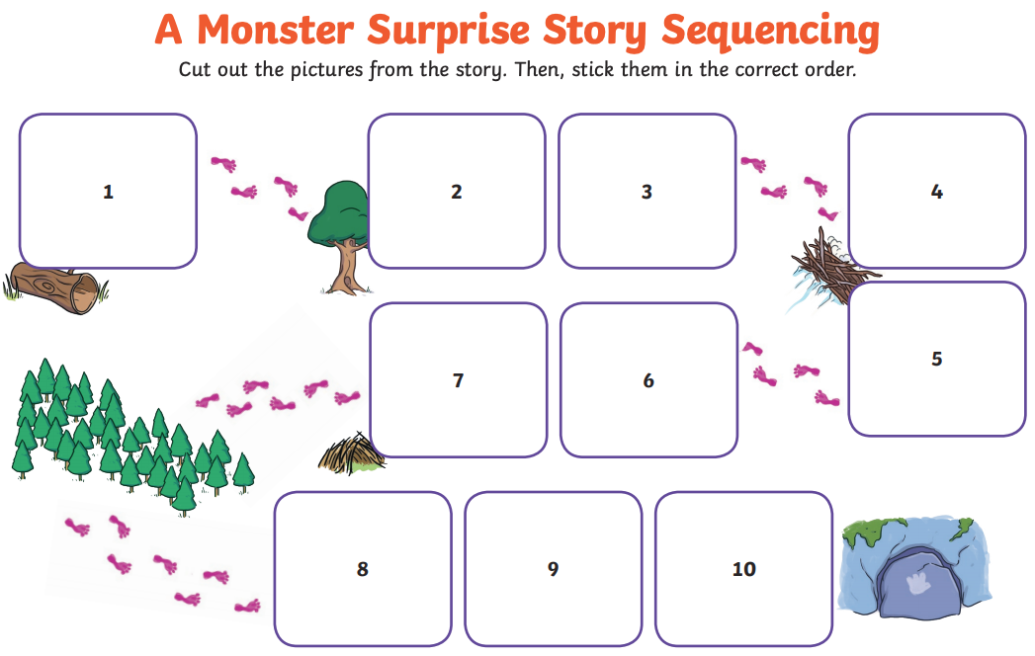
Cut out these pictures from the story and stick them onto your map in the correct order.


