
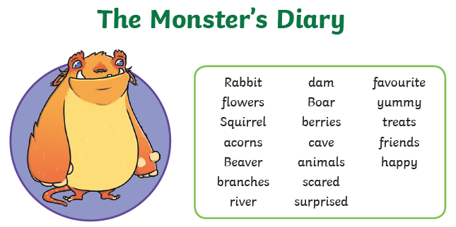
To make friends with the animals I put on a party.
Dear diary,
First, I got the

