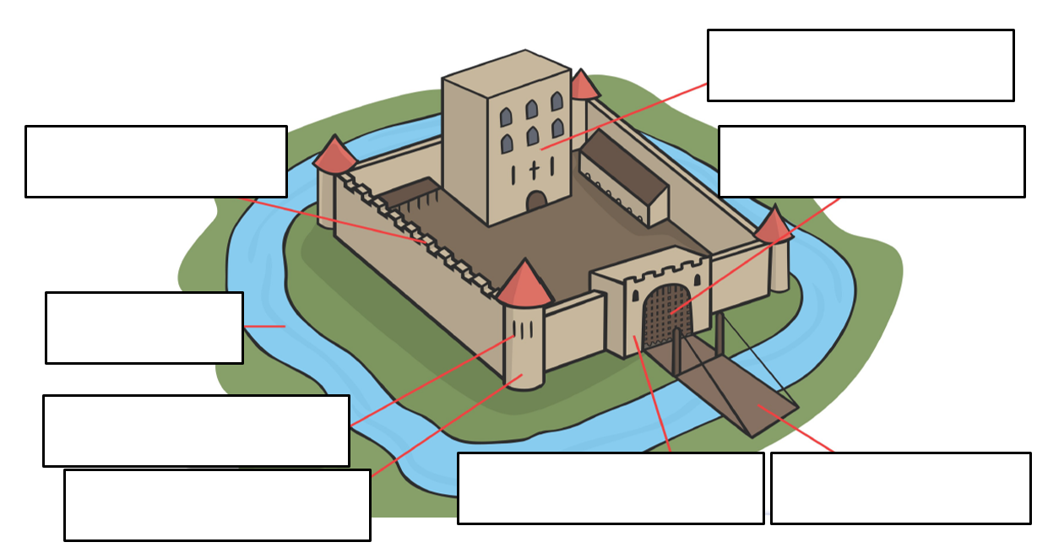
Word bank
arrow slits battlements barbican bailey moat drawbridge tower portcullis

