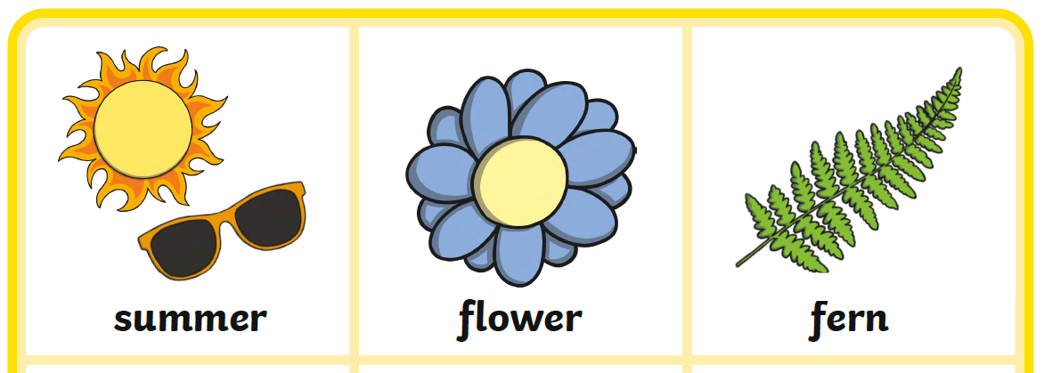
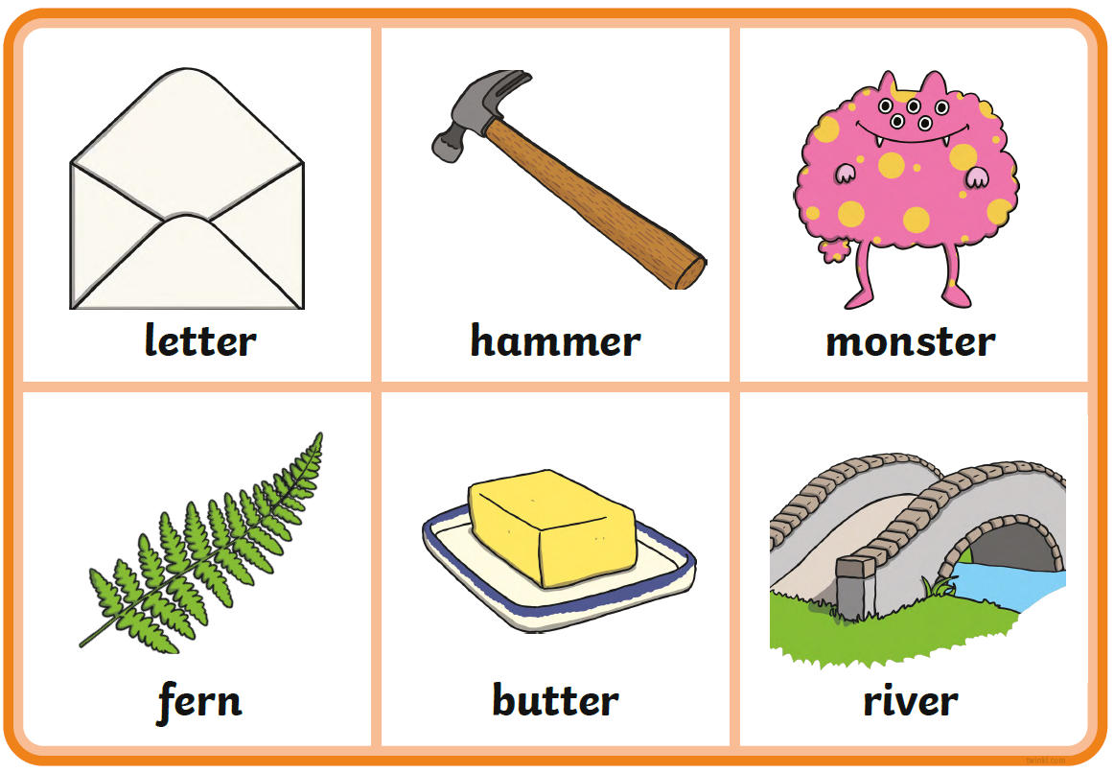
Can you fill in the missing er digraph to complete the words? Can you get an adult to help you read the words?
P3
f__________n
flow__________
summ__________
lett______
f______n
butt______
riv__________
monst______
hamm______
Can you say a sentence with an ‘er’ word in?

