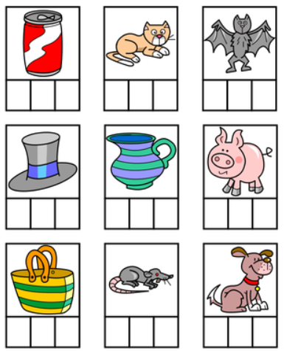
Can you say what the item is, segment the word and then spell it?
P4

