Week 1
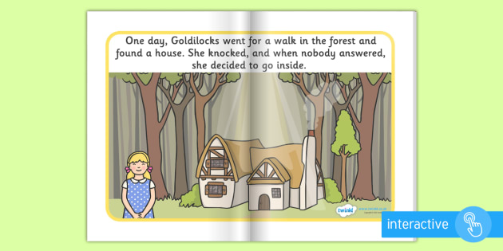
Day 1
Literacy

Listen to Mrs Burns read the story ‘Goldilocks and the three bears’
Colour in the character pictures

Maths –
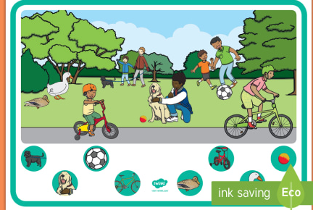
Watch the lesson introducing the language of big and small (on website) Can you sort your toys by size order?

Topic-

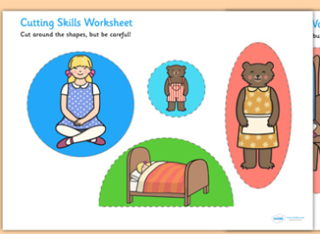
Use your super cutting skills to cup uo the goldilocks pictures. Make sure you are holding your scissors correctly.
.
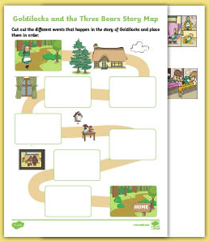
Day 2
Literacy -

Recap the story of goldilocks from yesterday.
Cut out the pictures and complete the story map. Can you use the story map to retell the story?

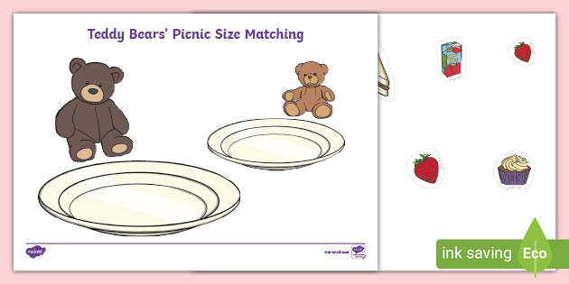
Maths – Big and small
The bears are having a picnic. Can you sort the foods that are big and small and give them to the correct bear.

Topic - Handprint Animals
Use brown/black poster paint to paint the palm of your hand.
Press the painted had down onto the paper.
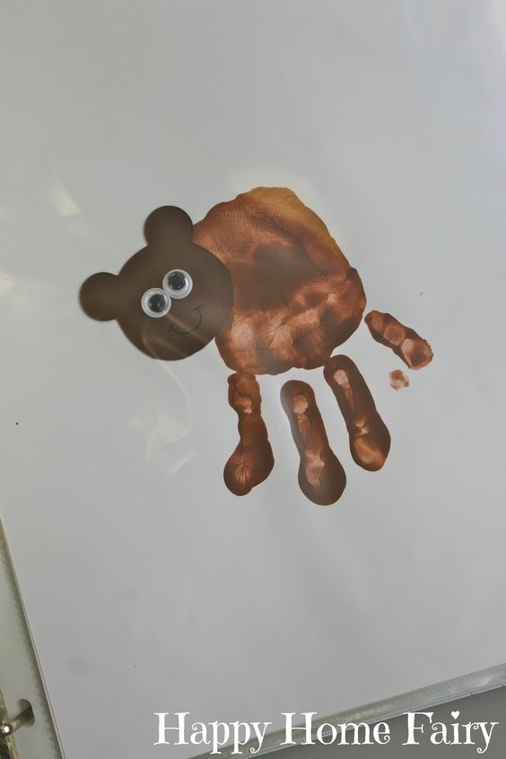
Over the thumb print a circle by stamping the heel of your hand (alternatively you could simply paint a brown circle over the thumb or glue a brown circle).
Paint your thumb or fingers to make two bear ears.
When the bear is dry stick on the googly eyes and draw a mouth and nose with the black pen

Day 3
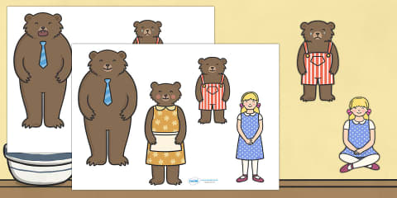
Literacy -
Listen to Mrs Burns read another version of the story Goldilocks and the three bears, Cut out and make puppets. Use to act out the story, can you use different voices for the characters?
Get a grown up to video your story and send it to our nursery email so we can all see your super story telling.

Maths
Sing the song when goldilocks went to the house of the bears emphasising the language of size. (video on website)
Play the game on top marks (click link) by sorting the clothes and dressing the bears correctly.
https://www.topmarks.co.uk/Flash.aspx?f=ThreeBears

Topic - Hard and soft sensory game

Instructions:
Place a range of mixed sized items in one large container
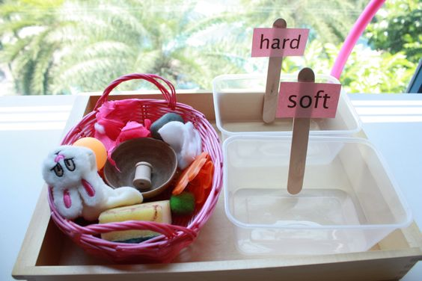
Set out another two bowls and label these bowls ‘hard’ and ‘Soft’
Your child can then sort the mixed items into the hard and soft bowls.
This activity can be extended to develop fine motor skills by the child using tweezers or tongues to pick up the items and dropping them into the bowls.
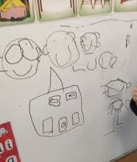
Day 4
Literacy –
What can you remember about the story?
Draw pictures of your favourite part of the story? Why is that your favourite? Grown-ups annotate what the child has said in their own words,

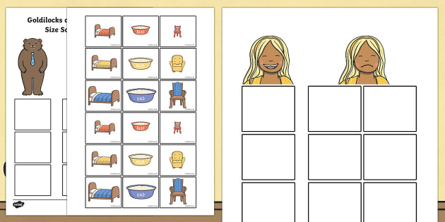
Maths –
Goldilocks has written a letter to say sorry to bears. Listen to Mrs Burns read it to you on the school website. Can you help her by sorting the pictures by size.

Topic
Today it’s time to give Goldilocks a haircut!
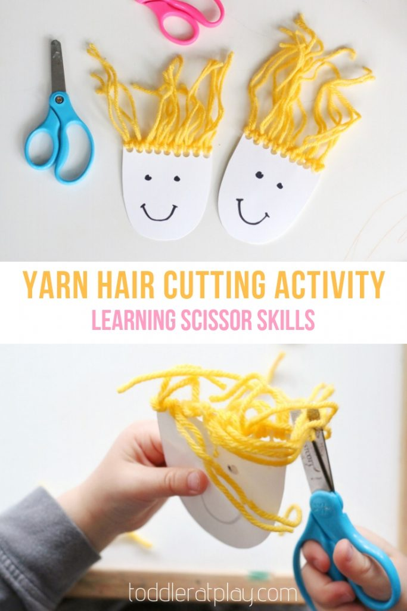
Instructions:
Using either a paper plate or piece of card use the hole punch to make several holes along the top edge (if you do not have a hole punch you can skip this step)
Cut wool or string into several long pieces (as long as you want and 1x piece of string per hole).
Thread the string/wool through the holes (if you did not use a hole punch then you could glue the string/wool to the top of the face. Threading is a good activity for the chid.
Use the paint / crayon / pen to draw eyes, a nose and a mouth
Now give goldilocks a haircut!
TEACHERS TIP: have the children only cut one string at a time and cut only a little off the length each time. This means they will be able to practise the activity several times.
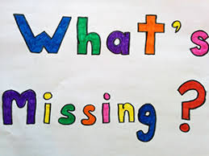
Day 5
Literacy
Oral blending segmenting
Watch the Mrs Burns’ phonics on the school website, Today Mrs’s Burns will be playing a game of “what’s missing” after the lesson you can use the sheet provided to play the game at home.

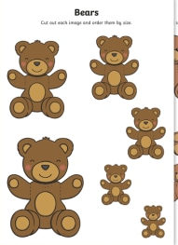
Maths

Can you cut out the bears and order them by size from biggest to smallest? Can you explain what you have done to an adult by using the correct vocabulary?

Topic


Feel Good Friday!
Watch Mrs Burns Video making play dough and see if you can join in and enjoy dough disco!

Week 2
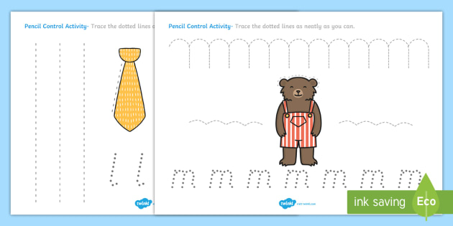
Day 1
Literacy – pencil control
Practise holding your pencil correctly! Follow the lines to complete the patterns,

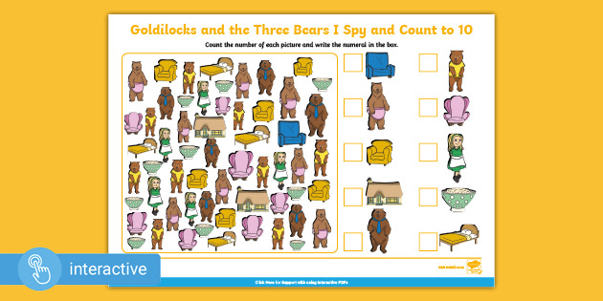
Maths –
Play eye spy and count! How many chairs can you find? How many houses? Write your numbers in the box. This sheet is available with numbers to 5 and numbers to 10 and can either be written on, on the printed sheet are typed on by accessing the sheet through the website.

Topic
A lovely activity for you to try at home during lockdown would be to make porridge as a family. Porridge doesn’t have to be eaten just at breakfast time but could be a lunchtime or evening treat. You could make a different porridge every day. This is a super language and measuring activity for the children. Use oats and mix with either milk or water depending on your preference. You could make a basic porridge and then add different things to the mix at the table as a way to introduce new foods to your child. Suggested additions to the porridge include:
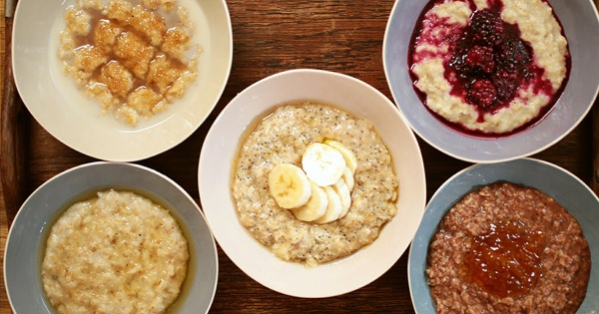
Honey,
Jam,
Raisins and other dried fruits,
Sliced banana (getting the children to slice the banana is a good fine motor control activity)
Berries such as sliced blueberries or strawberries,
A list of 10 healthy porridge toppings can be found at: https://www.independent.ie/life/food-drink/ten-healthiest-porridge-toppings-30588259.html
What is your favourite?
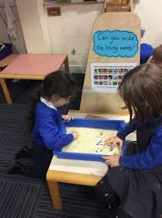
Day 2

Literacy –
Tip some left over porridge oats into a tray and use them to practise your mark making. See if you can write any letters from your name, Watch Mrs Burns practise her mark making on the video on the school website.

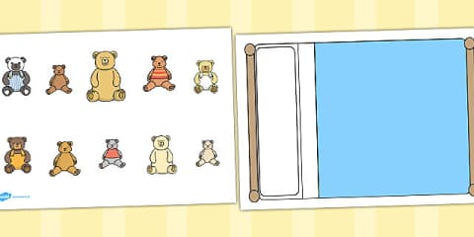
Maths –
Listen to Mrs Burns read the story ‘Ten Little Bears’
Cut out the bears and stick them in the bed? How many can you count?

Topic - Goldilocks Porridge Cutting and Sticking Activity
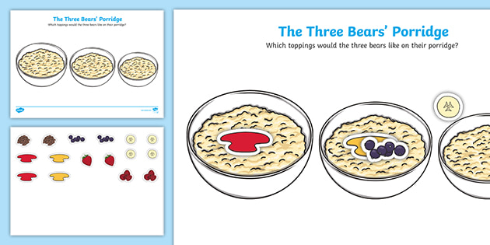
Cut out the different toppings.
Glue the toppings onto the porridge bowls.
You could then cut out the porridge bowls to give to your family.

Day 3
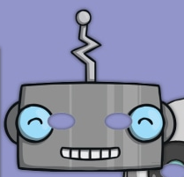
Literacy
Phonics – segmenting
Watch Mrs Burns’ Phonics! Today she is having a tea party with a robot! Maybe you can make your robot mask so you can have a robot tea party too!

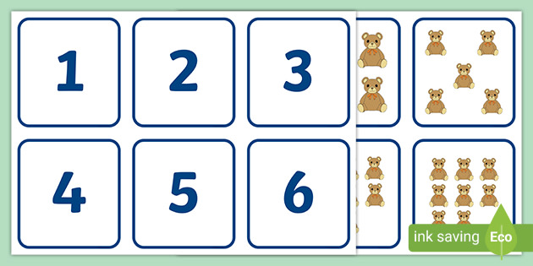
Maths –

Carefully count the bears and match them to their correct number.

Topic- Fork Paint Bear

Just like the snowflake art last week, you can use the same technique to make a bear’s face. You could make the three bear family with a baby (small), a mummy (medium) and a daddy (big). To do this you just use less paint for small and more paint for bigger bears. You could even use different sized forks like smaller cake forks and larger dinner forks to get a different effect and size.
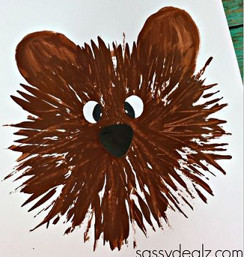
Instructions:
Pour a blob of paint onto the paper (small for baby, medium for mummy, big for daddy)
Use the fork to spread out the paint from the middle making a circle burst pattern.
Use fingertips or your thumbs to dip in paint and make the bears ears.

Day 4
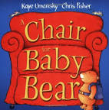
Literacy
Read the story a new chair for baby bear!
What kind of chair does baby bear want? Can you design a chair? What colour would it be? How would you make it comfy?

Maths

Watch the PowerPoint (school website) modelling ordering numbers to 10. Cut out the numbers and try to order numbers 0-10.
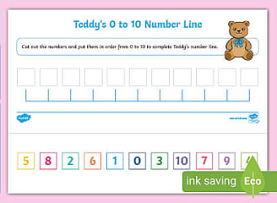

Topic - Goldilocks Pencil Control Maze
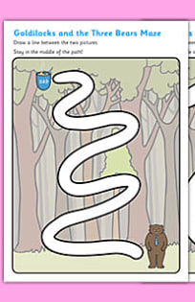
You will need:
Goldilocks pencil control maze sheets
Pencil / crayon / pen / paintbrush and paint
Instructions:
Starting at the top of the sheet, can you find your way to the end of the maze? Draw your path, you could even repeat the path using different colours or a different writing tool.

Day 5
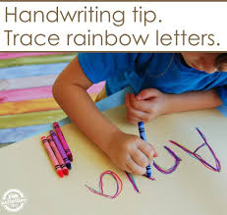
Literacy – name writing

Today look carefully at the letters in your name. Use different colours to write your name creating a rainbow effect.

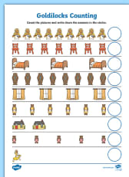
Maths –

Count the pictures and write the number, Use your finger to help you count carefully and accurately.

Topic– Baking

Today for our feel good Friday we will be baking flapjack! I have given you a recipe to follow and you can watch the video of Mrs Burns on the school website too! Enjoy!

