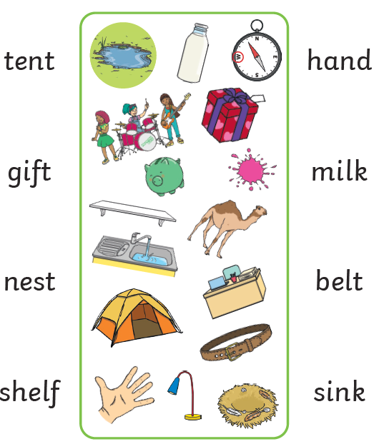
Read each word and match it to the right picture
P6

