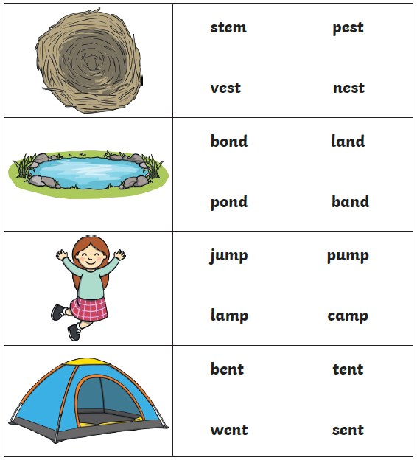
Circle the word that matches the picture
P7

