What’s missing?
Look at the pictures and name them together.
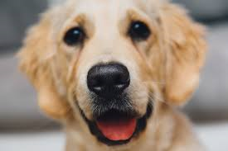  Dog | 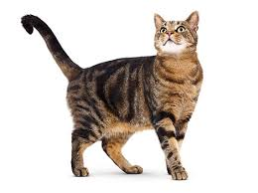  Cat |   Cup | 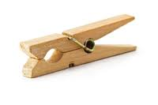  peg
Look again, which one is missing? Can you segment (sound out) the object that is missing?
Dog | Cat | peg
What is missing? _________________
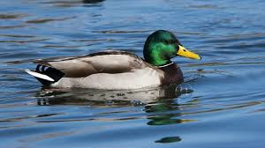  Duck | 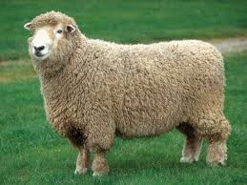  Cat | 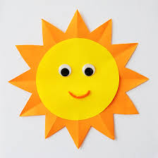  sun | 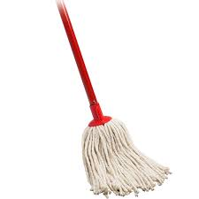  mop
Look again, which one is missing? Can you segment (sound out) the object that is missing?
Duck | sun | mop
What is missing? _________________

