Nursey home learning
Topic – A winter’s day

Day 1
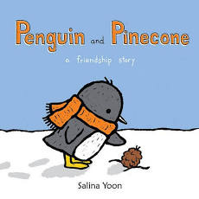
Literacy/phonics
Our core text this term is the penguin and the pine cone. Listen to the story via the you tube link -Penguin and Pinecone - A Friendship Story - YouTube
Talk about who are you friends? Draw a picture of you and your friends, ask a grown up to label your drawing.

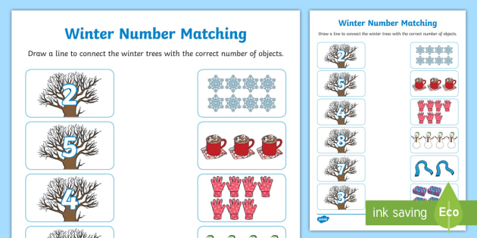
Maths – Counting and number recognition
Today practise counting at home. See if you can count to 5 and then to 10 using your fingers to count carefully. Use the winter number matching sheet to practise recognising your numbers. Don’t forget, count the pictures very carefully.

Creative/topic
Talk together about how the weather has changed now that it is winter. What clothes do we wear in winter?
sddddxsz
Play the clothes sorting game.
Discovery Education Espresso - Sorting: weather and clothes
Then using this sheet, cut out all of the pictures and see if you can sort them correctly!

Day 2
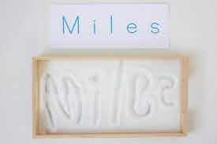
Literacy/phonics – Name writing

Today get a grown up to write your name clearly on a piece of paper. Using a tray of salt or sugar (snow) practise writing your names with your figure.

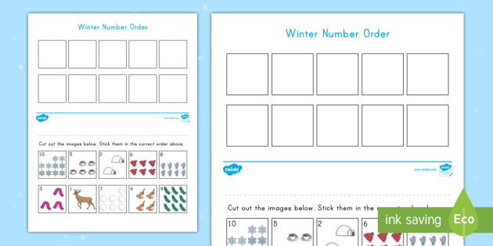
Maths – Number recognition and ordering

There are lots of counting games to play on busy things! Today I would like you to practise ordering numbers.
Try to cut out the numbers on the sheet and stick them in the correct order.
Count very carefully!

Creative/topic – PD - cutting
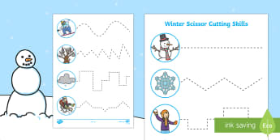
Today I would like you to practise your cutting skills! You can use the winter cutting sheet that I have provided or think of your own idea! Make sure you are holding those scissors correctly and safely.

Day 3-

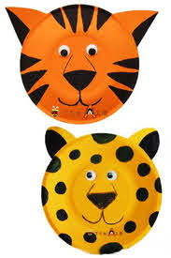
Literacy/phonics – Phonics – animal sounds and instrumental sounds

Begin by watching phonics with Maddison and Felix on you tube. This episode is all about animal and instrumental sounds. We have learnt a lot about different instruments in nursery and have been learning how to identify animals by the sound they make.
Phase 1 Phonics with Maddison and Felix - Animal Sounds - YouTube
Can you make an animal mask? You could use a paper plate if you have one. Decorate your plate using paints, pencil crayons or felt tips!

Maths- Number formation
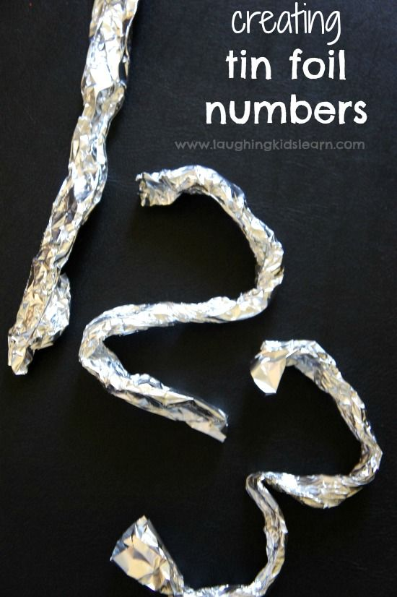
Today I would like you to practise writing numbers! A fun way to learn about number formation is to use tinfoil to create each number!
Then have a go at writing them, you can use the sheet provided. I have included the number formation rhymes we use in nursery too to help.

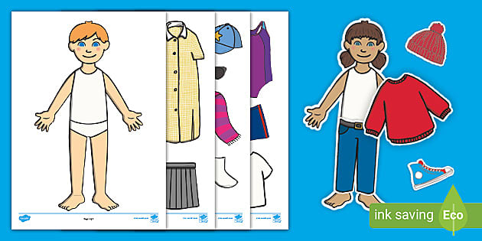
Creative/topic – PD cutting and UW seasons

Can you dress the people ready for a winter? Choose the correct clothing and carefully cut them out.

Day 4
Literacy/phonics- Phonics – environmental/animal sounds

First login to Phonics play- www.phonicsplay.co.uk
Username – Whitefield123
Password- apple123
Go to resources and select phase 1.
First press the ‘meet the animals’ Listen together to all the animal sounds, can your child name them? Can they copy the animal sounds?
Play the game guess the sounds – children to select the animal they can hear

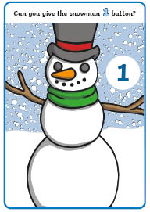
Maths – counting and number recognition
Watch the number rhyme – 5 little snowman. Try to use your fingers to count how many snowmen are left.
5 Little Snowmen Standing in a Row | Snowman Songs for Children | Lyric Video | The Kiboomers - YouTube

Use the sheets provided. Can you give the snowman the correct number of buttons? You could make buttons out of playdough, use buttons or coins, or draw them.

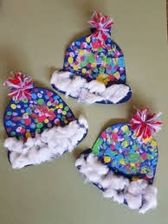
Creative/topic – EAD-exploring media and materials UW- seasons

Can you create your own winter hat? Think carefully about how you want it to look? You could use paint, colouring pencils, crayons and different collage materials!

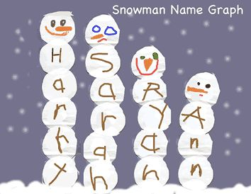
Day 5

Literacy/phonics – Writing
Today, try to create a snowman using the letters from your name! If this is a bit tricky, practise the first letter of your name lots of times to build your snowman


Maths – Number formation
Today practise your number formation! You could use, salt or sugar to make some fake snow! Then use your finger to practise writing your numbers.

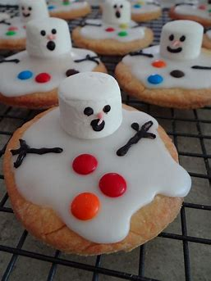
Creative/topic – Baking

Can you make a winter biscuit? You could decorate a plain biscuit you already have or bake your own.

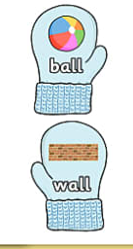
Week 2
Day 1
Literacy/phonics – Rhythm and rhyme
Begin by watching Phase 1 phonics – rhythm and rhyme with Maddison.
Phase 1 Phonics with Maddison and Felix - Rhythm and Rhyme - YouTube
Ask a grown up to cut out the rhyming mittons. Work together to match the rhyming pairs.
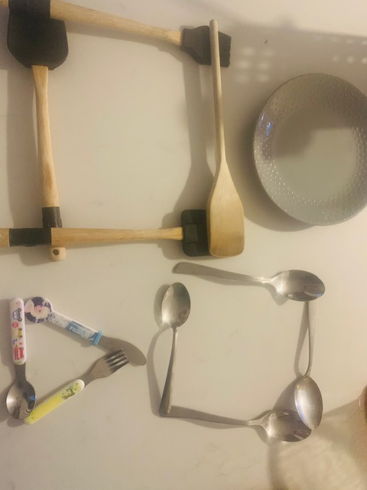
Maths – Shape
Log in to Espresso
Username - student18029
Password- nwi123
Watch the following video all about shapes -
Discovery Education Espresso - Maths - Shape - Flat shapes - Flat shapes
Using items around your house, can you make some 2D shapes? I made some shapes using cutlery from my kitchen, what will you use?

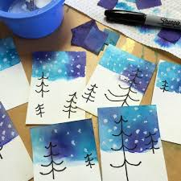
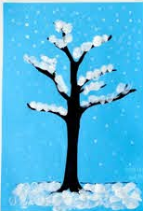
Creative/topic – UW-seasons EAD- exploring media and materials
Log in to Espresso
Username - student18029
Password- nwi123
Discovery Education Espresso - Foundation - Understanding the world - Weather - Videos - Seasons
Can you create a wintery picture? Think about what colours you should use. You could use pencils, felt tips, paints or any
craft or recycled materials you have around your house. Be creative!
Day 2
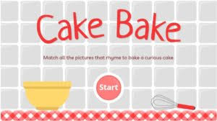
Literacy/phonics – Phonics, Phase 1 alliteration

First login to Phonics play- www.phonicsplay.co.uk
Username – Whitefield123
Password- apple123
Go to resources and select phase 1 and select the game cake bake.
Can you add all of the rhyming word to create a rhyming cake?
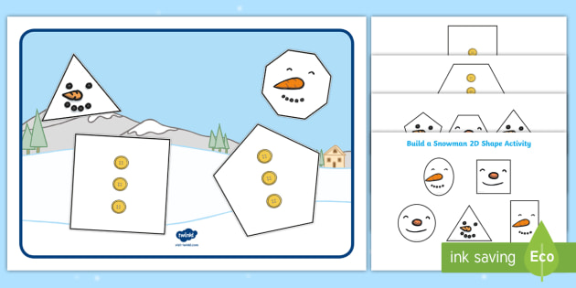
Maths – shape

Recap the names of shapes using the provided flash cards
Cut out the snow man shapes and use them to build shape snowman. What shapes have you used?

Creative/topic – PD-cutting
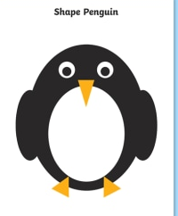
Today I would like you to practise your cutting skills!
Cut out the shapes and use them to create a penguin picture!

Day 3
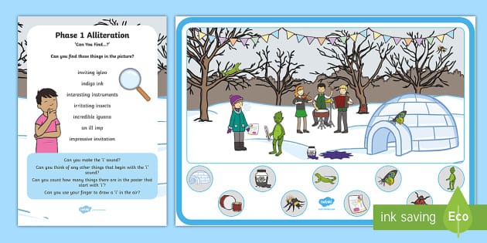
Literacy/phonics – Alliteration
Today we are learning about alliteration. First watch the phonics lesson about alliteration on youtube
Phase 1 Phonics with Maddison and Felix - Alliteration – YouTube
Using the picture provided, see if you van fins all of the items that begin with ‘I’

Maths – patterns

Today we are going to learn all about repeated patters,
First log in to Espresso
Username - student18029
Password- nwi123
Watch this video clip about patterns. Can you use any household items or toys to create a repeated pattern?
Discovery Education Espresso - Foundation - Mathematics - Problem solving - People patterns
Now try and make your own patterns using this game:
Discovery Education Espresso - Shape patterns


Creative/topic – PD fine motor skills

Today have a go at the dough disco! Use playdough to exercise those fingers! Follow the link for instructuons.

Dough Disco Nursery Rhyme - The Muffin Man - YouTube

Day 4

Literacy/phonics – Alliteration

First login to Phonics play- www.phonicsplay.co.uk
Username – Whitefield123
Password- apple123
Go to resources and select phase 1
Play the ‘super smoothie’ game by selecting all the pictures that begin with the same letter.

Maths – pattern

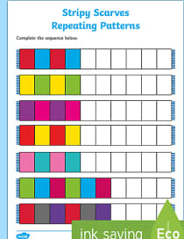
Today, colour the scarves to complete the pattern.

Can you draw your own patterns?

Creative/topic – UW-seasons EAD- exploring media and materials
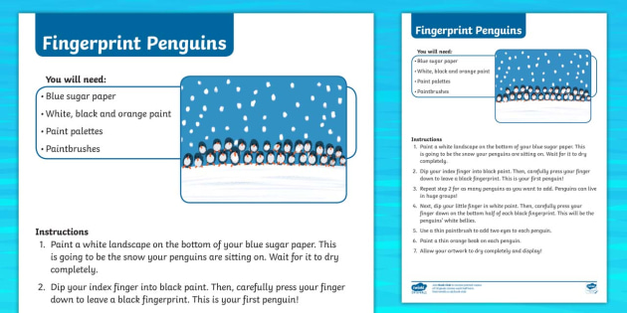

Today see if you can use you fingers to make a snowy picture. You could try to make some fin.gerprint penguins

YOU WILL NEED TO PREPARE TOMORROWS ICE CHALLENGE TODAY
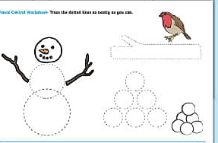
Day 5

Literacy/phonics – pencil control
Today let practice your pencil control! follow the lines to make a winter picture. Don’t forget to hold your pencil correctly.

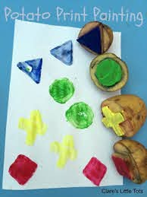
Maths – Pattern/shape D

Today have a go at making some shape stamps using potatoes. See if you can use your stamps and some paint to create your own shape pattern.

Creative/topic – ice challenge
Preparation – Find a container that you can fit in the freezer fill it with water. Add glitter even a small plastic toy and put it in the freezer to freeze overnight.

Using your frozen creation explore the ice and ways it can melt.
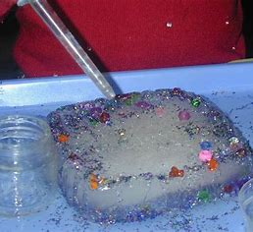
What happens when you add cold water?
What happens when you add warm water?
What happens if you add salt?

