Day 1
Literacy
Listen to Mrs Burns read this weeks text ‘Ten little lights’ (This will be found on the school website. You also have printed copy in your pack)
Talk about the story together
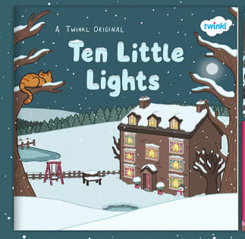
What is the weather like?
Who let the animals in the house?
How many lights are on in by the end of the story?
What do you like about snow?

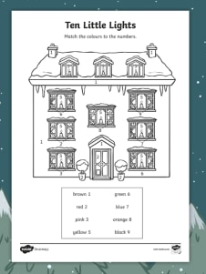
Maths – Number recognition
Practise counting to 10. Can you do ten jumps? Ten claps? Ten hops? Get a grown up to take a video of your super counting and email us.
Colour the picture by carefully looking at the numbers!

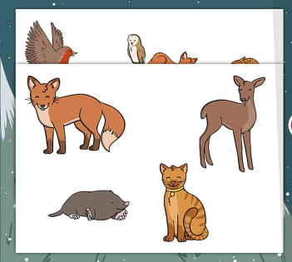
Topic – animals
Look at the photograph provided of the animals from the story. Can you name them? Can you find out any information about them. Using the pictures provided (or you could draw your own) make some animal puppets. Cut out the pictures and stick them on a lolly stick, a stick from the garden or even a pencil. Use your puppets to retell the story.

Day 2
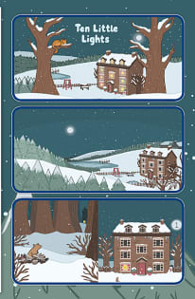
Literacy – story sequence

Recap yesterday’s story. Cut up the pictures provided and see if you can put them in the correct order. Use your pictures to retell the story.

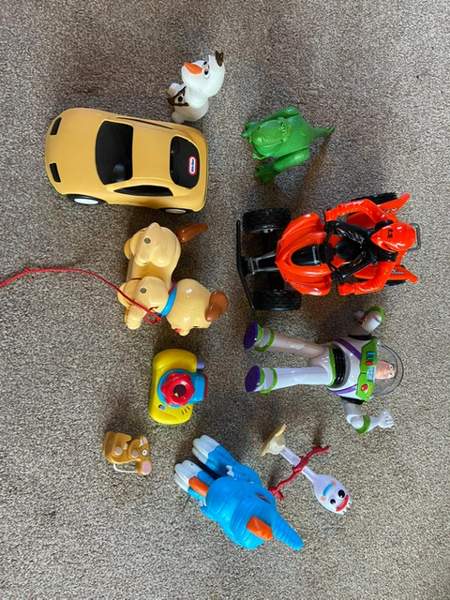
This is my toy collection! I have counted 10 toys carefully!
Maths - Counting

In the story ‘Ten Little Lights’, there are 10 woodland animals in the snow. Can you count to 10? You could line up 10 toys and try to count them all. Touch each toy as you count it. Watch Mrs Burns us a ten frame to help her count. Email us some pictures of your toy collections!

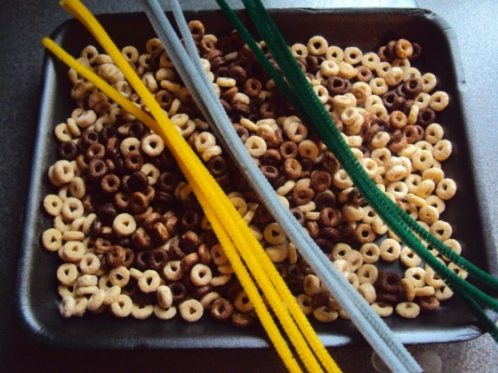
Topic
When the trees and ground are cold and snowy, animals sometimes find it hard to find food. Could you help the birds by making a bird feeder? Thread some hooped cereal onto a piece of string or a pipe cleaner and hang it in your garden or outside your window. The birds will love this winter snack! Watch the video of Mrs Burns making a bird feeder!
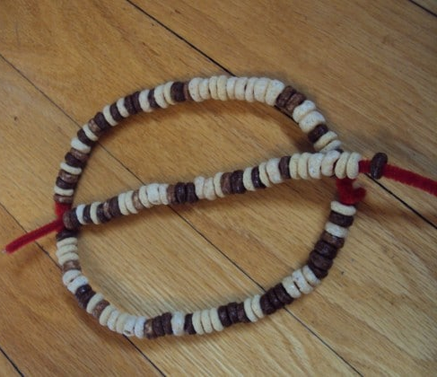
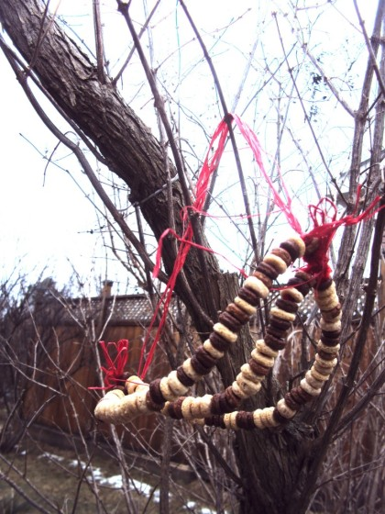

Day 3
Literacy - Pencil control
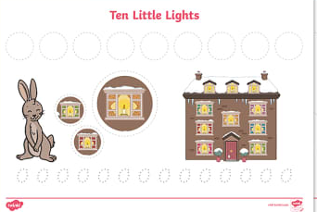
Use a pencil or felt tip to follow the pencil control patterns. Remember to hold your pencil using the correct grip.

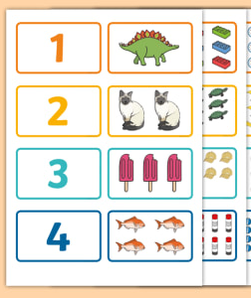
Maths – counting

Listen to Mrs Burns read the story ‘One Ted Fell Out Of Bed’ (video on school website)
Cut out the pictures. Can you match the number to the quantity? Remember carful counting!

Topic – Dough gym

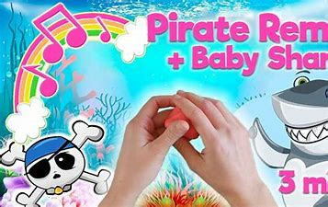
It’s time for this week’s Dough Gym! Grab some playdough, follow the instructions and enjoy!
Pirate Playdough remix: Row your Boat, Pirate dance, Baby Shark Nursery Rhyme/Dough mashup - YouTube

Day 4 –
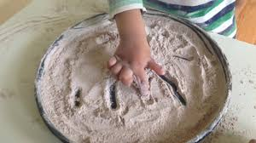
Literacy –

Have you ever seen snow? What did it look and feel like? Pour a little pile of flour onto the table and pretend it is snow. Can you smooth it out with your hands? Try to make some patterns in the snow or maybe write your name.

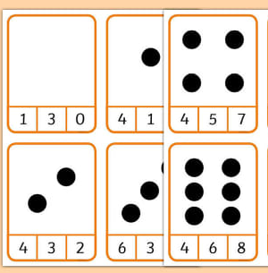
Maths – counting pegs

Using your flash cards and some clothes pegs, select the correct number on your flash card! See if you can add pegs to your other flash cards counting out values to 10.

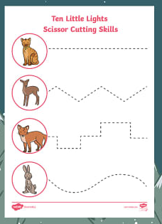
Topic - cutting (PD)

Today I would like you to practice your cutting! Make sure you hold your scissors correctly and carefully follow the lines.

Day 5 –
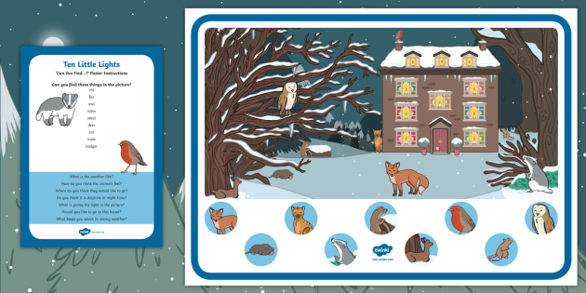
Literacy
Look really carefully at the picture. Can you find all the animals from the story?
Try to speak in a full sentence
“I can see the fox”
“ I have found the owl”

Maths –
Number formation
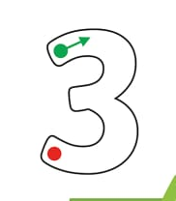
Today I want you practice your number formation. Use felt tips or pencil crayons to make ‘rainbow’ numbers. I have modelled how to do this on a video on the school website.

Topic – PSED/Baking – ‘Feel good Friday’
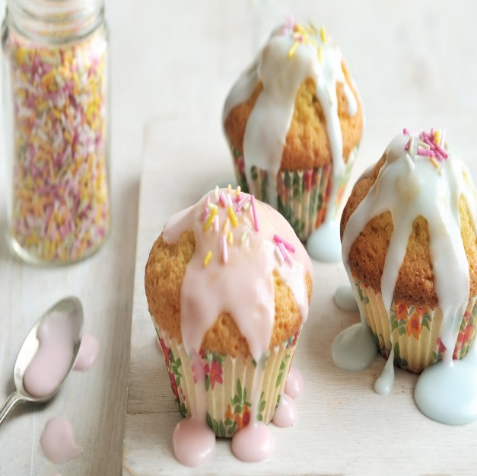
Baking is one of the things that makes me happy! Watch the video of Mrs Burns baking. I have included a recipe for you to try at home or of course you can make something else yummy! Have fun!!

Week 2
Day 1

Literacy - Phonics oral blending segmenting

Watch phonics with Mrs Burns on the school website. We are learning all about oral blending!
Collect some items together and practice your oral blending at home.
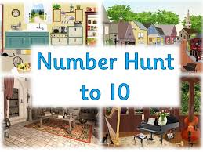
Maths – ordering numbers
Number hunt
get a grown up to hide your number cards around your house. Go on a number hunt to find them. Once you have found them see if you can out them in the right order.

Topic – PSED
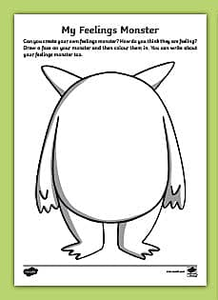
Listen to Mrs Burns read the story ‘My monster and me’

Colour in your own feelings monster!

Day 2 –
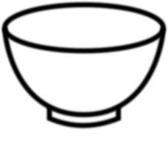
Literacy – phonics
Watch phonics with Mrs Burns on the school website. Today she is making a very silly soup. You can find some objects around the house to make a silly soup or you can use the pictures provided to create your own. See if you can use your oral blending skills to create your soup.
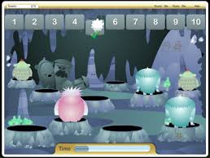

Maths – Counting
Click on the link – practice counting the yetis and select the correct number to represent.
'Count the Yeti 1 to 10' (themathsfactor.com)

Topic – PSED

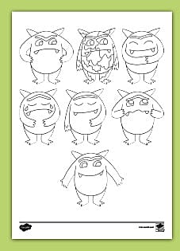
Listen to Mrs Burns read the story ‘The colour monster’
See if you can colour all the monsters in the correct colour? Do they look happy –Yellow? Or do they look angry –red? Or maybe they look calm – green?

Day 3
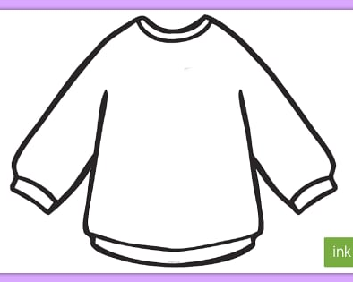
Literacy - Pencil control.
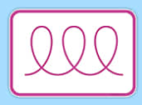
Today we are designing our own jumper. Pick a pattern card and copy the pattern on your jumper. Watch the video of Mrs Burns Modeling this activity.

Maths –
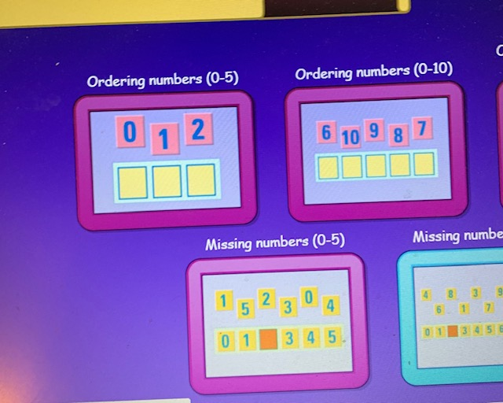
Log in to espresso
www.discoveryeducation.co.uk
Username - student18029
Password- nwi123
Practise ordering the numbers 1-5 and then 1-10
Discovery Education Espresso - Foundation - Mathematics - Numbers 0 to 20 - Activities

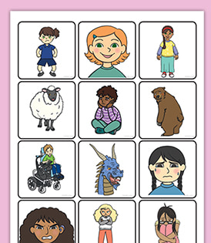
Topic – PSED

Today see if you can sort the pictures by emotion. Look carefully at the facial expressions. Do they look happy, sad or angry?


Day 4

Literacy – phonics -
Watch Mrs Burns model oral blending with our game “I went to the shop”

Maths –
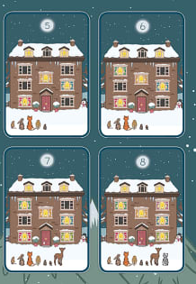
Ordering numbers

Yesterday you used the espresso game to practice ordering numbers. Today see if you can order the number cards 1-10.

Topic -

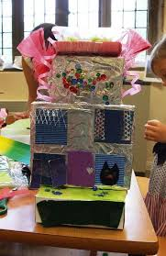
Today I want you to get crafty with your recycling! Can you build a house? I can’t wait to see pictures of your wonderful creations!
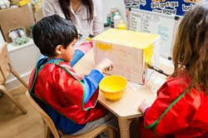

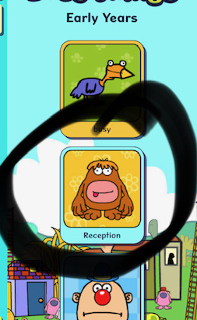
Day 10
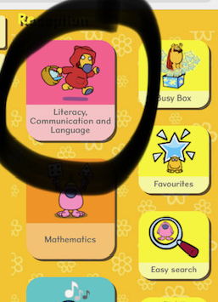
Literacy
Today we are continuing our learning about ‘oral blending’. Log into busy things and play the ‘feed the monster game’
Log into busythings
Route: busythings.co.uk
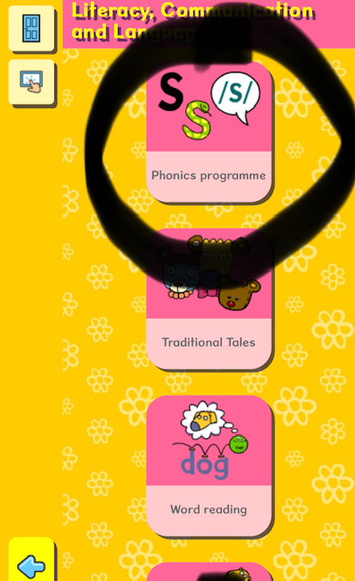
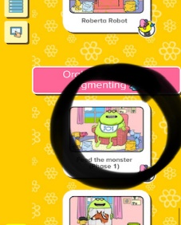
Username - home2496
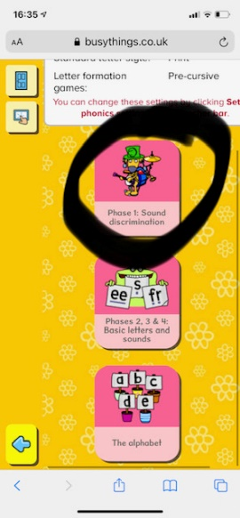
Password- blue2171

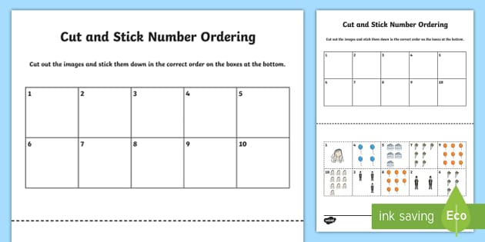
Maths
Cut out the pictures and order the numbers to 10. Make sure you so careful counting.

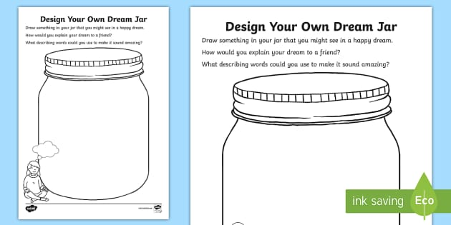
Topic – PSED – ‘Feel good Friday’
Today I want you to think about all of the things that make you happy! Create a happy jar. You can either decorate an old jar or draw pictures on the sheet provided. Watch the video of Mrs Burns making her happy Jar.

Today I want you to get crafty with your recycling! Can you build a house? I can’t wait to see pictures of your wonderful creations!

