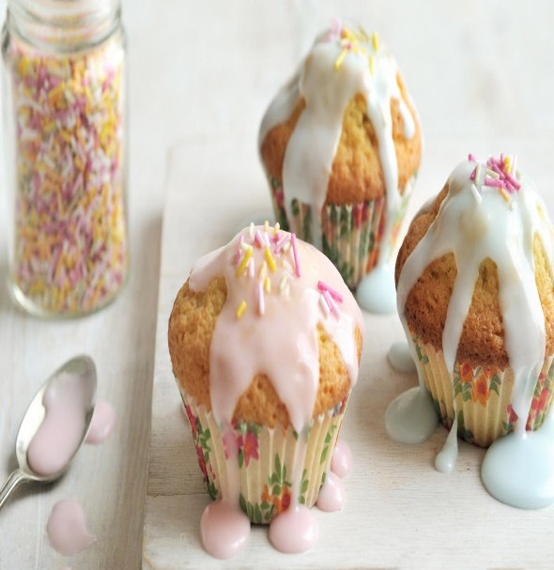
Ingredients
- 110g/4oz butter or margarine, softened at room temperature
- 110g/4oz caster sugar
- 2 free-range eggs, lightly beaten
- 1 tsp vanilla extract
- 110g/4oz self-raising flour
- 1-2 tbsp milk

For the icing
- 300g/10½oz icing sugar
- 2-3 tbsp water
- 2-3 drops food colouring
- hundreds and thousands, or other cake decorations

Method
- Preheat the oven to 180C/350F/Gas 4 and line 2 x 12-hole fairy cake tins with paper cases.
- Cream the butter and sugar together in a bowl until pale. Beat in the eggs, a little at a time, and stir in the vanilla extract.
- Fold in the flour using a large metal spoon. Add a little milk until the mixture is a soft dropping consistency and spoon the mixture into the paper cases until they are half full.
- Bake in the oven for 8-10 minutes, or until golden-brown on top and a skewer inserted into one of the cakes comes out clean. Set aside to cool for 10 minutes, then remove from the tin and cool on a wire rack.
- For the icing, sift the icing sugar into a large mixing bowl and stir in enough water to create a smooth mixture. Stir in the food colouring.
- To ice the fairy cakes, drizzle the icing over the cakes, sprinkle with decorations and set aside until the icing hardens.

