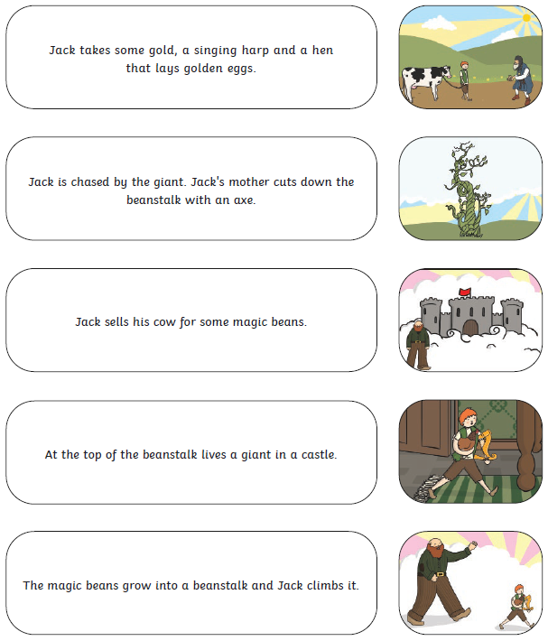
Can you read the captions and match them to the right picture?
R2

