Day 1

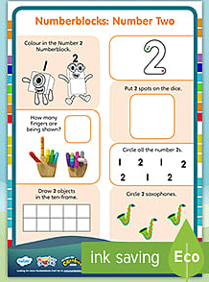
Maths
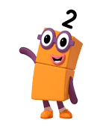
For this next two weeks our maths learning will be based on the popular children’s show ‘Number blocks’. Looking at numbers individually helps children to develop a greater understanding of number.
Watch the number blocks episode all about number 2 on YouTube -
https://www.youtube.com/watch?v=xyRFdFSGsgQ&safe=active
Complete the work sheets provided.
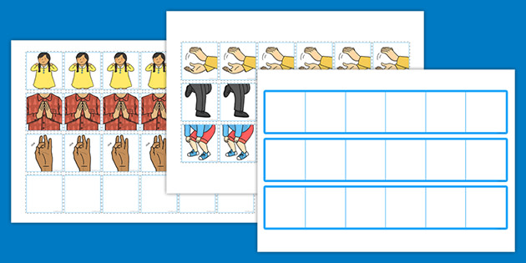
Literacy – Phonics body percussion
Watch phonics with Maddie on you tube. Today we are learning all about making sounds with our bodies. Cut out the pictures and use them to make up your own body percussion compositions such as clap clap click stamp…
https://www.youtube.com/watch?v=QqBHPT5uTP8&safe=active

Topic/creative
Follow the instructions to make your own playdough! Carefully measure your ingredients. Use food colouring or even paint to create different colours.
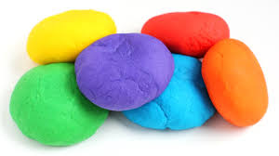
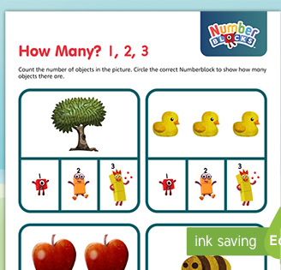
Day 2
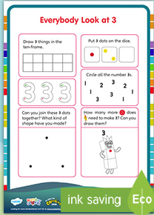
Maths
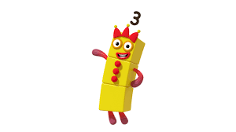
Today we are looking at number 3!
Watch the YouTube video and complete the activities.
https://www.youtube.com/watch?v=Bkufsme9qiA&safe=active

Literacy
Today we are continuing looking at body percussion.
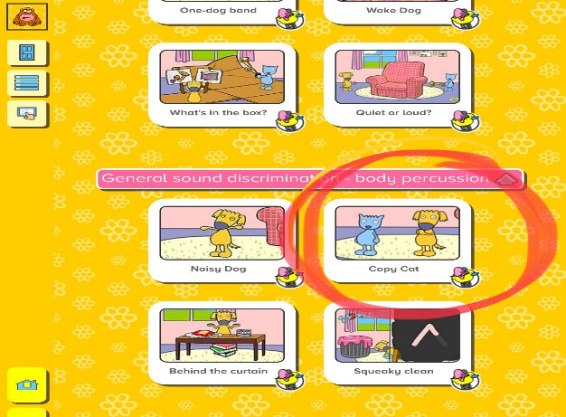
Log into busythings
Route: busythings.co.uk
Username - home2496
Password- blue2171
Click, reception, literacy, phonics, phase1 and then scroll down to body percussion to play the ‘copycat’ game. See if you can play copycat with your parents or brothers and sisters.


Topic/creative – physical development

Use your playdough from yesterday to join in with play dough disco! Playing with playdough helps to strengthen hand muscles! Join in with the song and then see what you can make using your playdough!

'I like to' playdough action song - YouTube

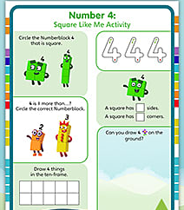
Day 3
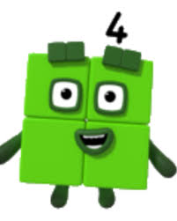
Maths

Today we are looking at number 4!
Watch the YouTube video and complete the activities.
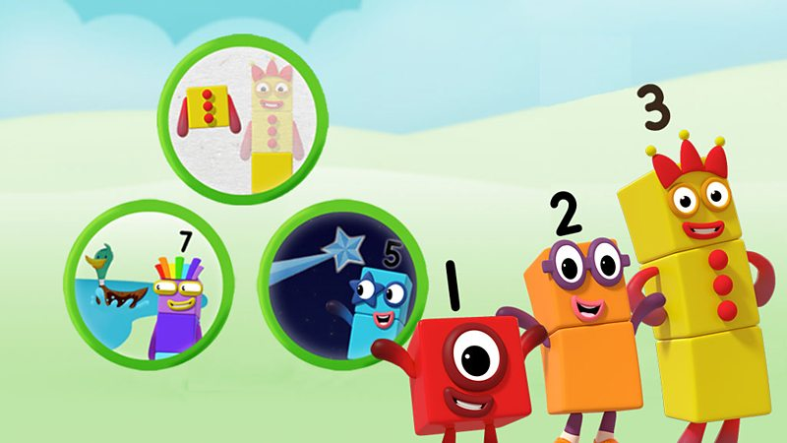
https://www.youtube.com/watch?v=Xket7YPSCYk&safe=active

Play this fun interactive Number block game on Cbeebies
https://www.bbc.co.uk/cbeebies/games/numberblocks-make-and-play

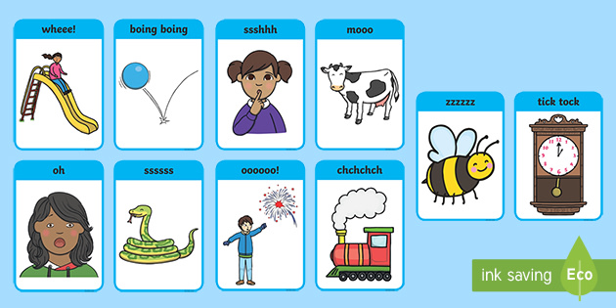
Literacy-Voice sounds

Today we are learning all about voice sounds. This means when we use our voices to make different sounds. Watch phonics with Maddie on YouTube. Use the picture flash cards to practise making different sounds.
https://www.youtube.com/watch?v=g8u84XGhRgo&safe=active
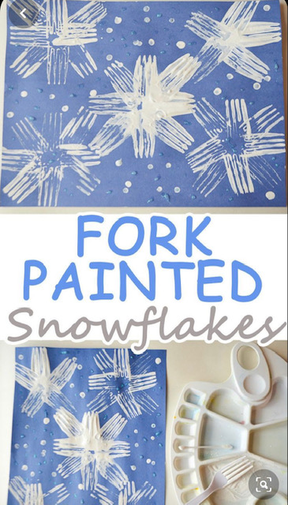
Topic/creative – winter
Sing the snowflake song from youtube
Little Snowflake (Extended Mix - 30 Mins!) | Kids Songs | Super Simple Songs - YouTube

Can you make a snowflake picture? The one pictured has been made by making marks in pain using a fork!

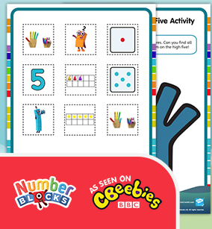
Day 4
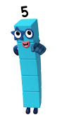
Maths
Today we are looking at number 5!
Watch the YouTube video and complete the activities
https://www.youtube.com/watch?v=YpH2W3fgUJs&safe=active

Literacy – pencil control
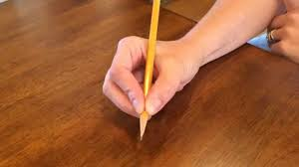
Today I would like you to practise holding your pencil correctly and making some lovely marks. Watch the video and join to warm up those fingers!
https://www.youtube.com/watch?v=N6kPcQSSsEY&safe=active

Topic/creative- Understanding of the world

Log in to espresso

www.discoveryeducation.co.uk
Username - student18029
Password- nwi123
Watch the videos about different types of weather.
Discovery Education Espresso - Foundation - Understanding the world - Weather - Videos
Look at the word bank together and colour the pictures.

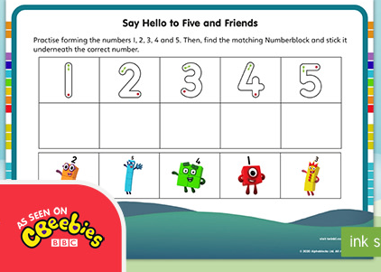
Day 5

Maths –
Today we are continuing to look at number 5. Look on the school website to find ‘the number 5’ PowerPoint presentation and work through it together. Then order the number blocks 1-5 on the sheet provided.

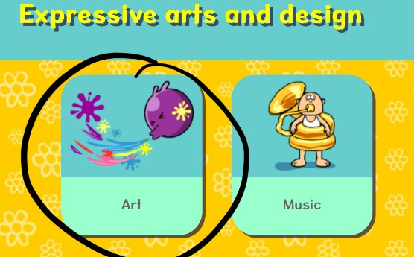
Literacy
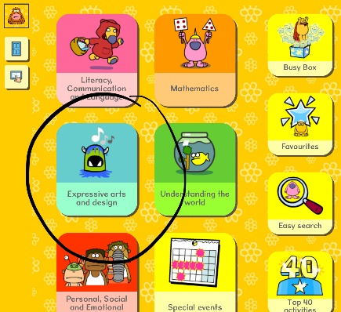
Today we are looking at different lines! Play the ‘lively lines’ game on busy things Log into busythings
Route: busythings.co.uk
Username - home2496
Password- blue2171
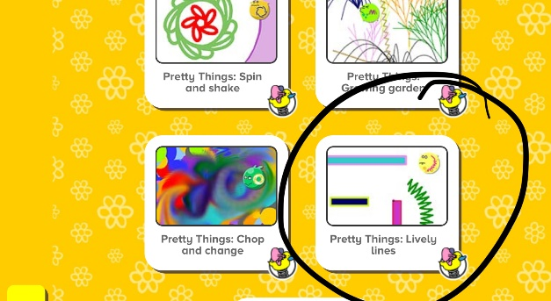
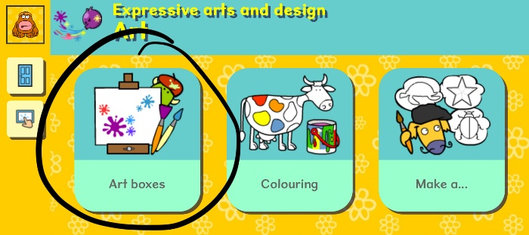

Topic/creative
Talk about different types of weather. What is the weather like today? Work together to make a weather chart – make a simple chart and draw a weather symbol for the different weather in a day /week – sunny, cloudy, windy, raining, thunder. Make up your own symbols and make up symbols for cold, warm, hot.

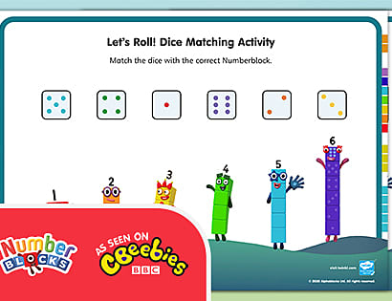
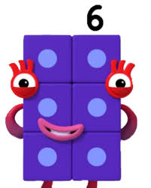
Day 6

Maths
Today we are looking at number 6!
Watch the YouTube video and complete the activities
https://www.youtube.com/watch?v=kak7S7zC604&safe=active

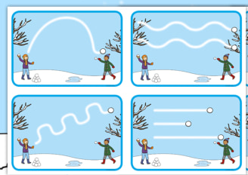
Literacy

Today please practise your pencil control using the provided winter patterns. Don’t forget to hold your pencil correctly!

Topic/creative –PD
Today it’s time to practise your cutting skills! Cut out the weather pictures carefully. Make sure you hold your scissors carefully, just how we have shown you in nursery.

Day 7
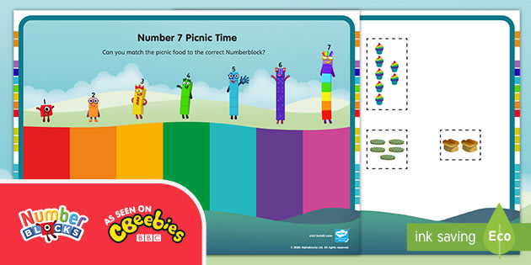

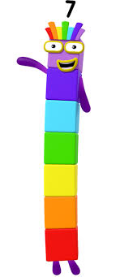
Maths
Today we are looking at number 7!
Watch the YouTube video and complete the activities
https://www.youtube.com/watch?v=ZfCwF0ns5YE&safe=active

Literacy – Handwriting – name writing
Log in to Espresso
Route: www.discoveryeducation.co.uk
Username - student18029
Password- nwi123
http://espresso.education.btlsl.co.uk/espresso/primary_uk/subject/module/video_index/item1244120/gradef/index.html
Use the handwriting tools to model correct formation of letters in your name. Begin with a capital letter at the beginning and see how many letters from your name you can write today.

Topic/creative –
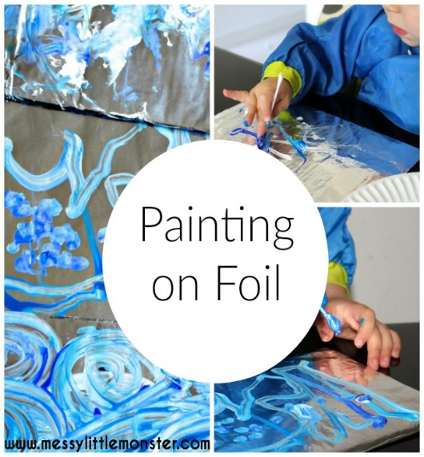
Use paint and kitchen foil to make a winter painting. You could try painting with different things such as cotton buds, small brushes or your fingers! Practise making different types of lines such as wavy lines and zig zag lines!

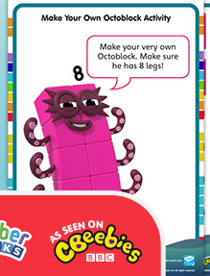
Day 8 –

Maths
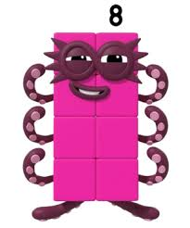
Today we are looking at number 8!
Watch the YouTube video and complete the activities

https://www.youtube.com/watch?v=uTPcwli2MH4&safe=active

Literacy -phonics oral blending and segmenting
Today it’s time to practise oral blending. This means when children can orally blend sounds to make a word eg, c-a-t = cat
This is a tricky skill to learn however blending is a very important early reading skills. Watch the video and join in with the activities.
Phase 1 Phonics with Maddison and Felix - Oral Blending - YouTube

Topic/creative
Story time with Mrs Burns - ‘The Runaway Iceberg” you will find this story on the school website on the nursery page.
Talk about the story together,
Did you like the story?
How was Rossi a good friend?
Can you remember any of the animals from the story?

I have included some colouring sheets for you to complete.

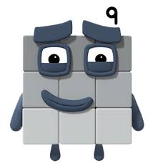
Day 9

Maths Today we are looking at number 9!
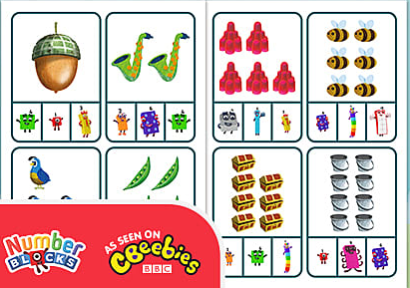
https://www.youtube.com/watch?v=XohzkDMAq5k&safe=active
Using the resource available, select the correct number block to match the image. You could draw a circle, use a counter or clip on a clothes peg!

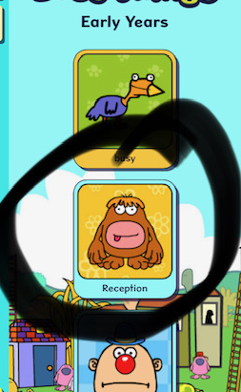
Literacy
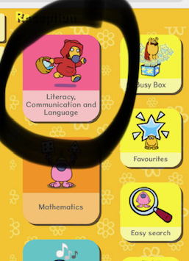
Today we are continuing our learning about ‘oral blenidng’. Log into busy things and play the ‘feed the monster game’
Log into busythings
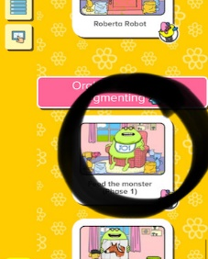
Route: busythings.co.uk
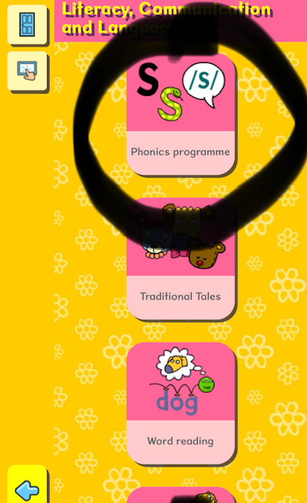
Username - home2496
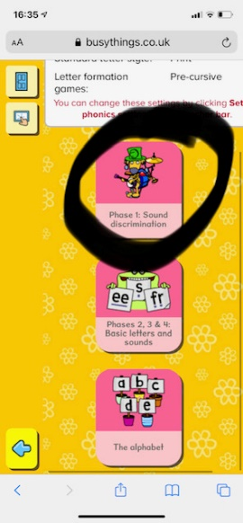
Password- blue2171

Topic/creative – music

Sing along with Mrs Burns (not very well im afraid) Video will be on the school website.
To learn our new little penguin song.

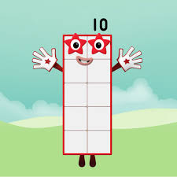
Day 10

Maths
Today we are looking at number 9!

https://www.youtube.com/watch?v=k4i6fu0bTQ8&safe=active
Today I would like you practise writing your numbers. Make sure you start from the red dot.
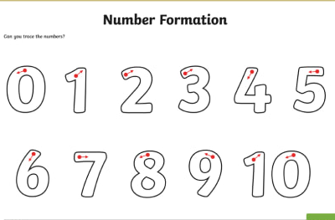

Literacy
Play metal mike with Mrs Burns! The video has been loaded on the school website so that you can join in!
Use the picture cards included to practise oral blending at home.

Topic/creative – music and movement

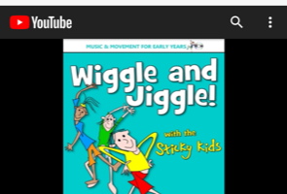
Sticky Kids - Wiggles and Jiggles - YouTube
Join with the sticky kid’s song ‘Wiggle and jiggle’

